

Requirement & Design Specification

FreshFriends
Smart Household Food Management System
Version: 1.0

– Danang, May 2026 –

Record of Changes
Version | Date | A*  M, D | In charge | Change Description
V1.0 | 26/5 | A | MyVP
*A - Added M - Modified D - Deleted

Contents
Record of Changes 2
I. Overview 4
1. User Requirements 4
1.1 Actors 4
1.2 Use Cases 4
2. Overall Functionalities 5
2.1 Screens Flow 5
2.2 Screen Descriptions 5
2.3 Screen Authorization 5
2.4 Non-UI Functions 6
3. System High Level Design 6
3.1 Database Design 6
3.2 Code Packages 7
II. Requirement Specifications 8
1. <<Feature Name>> 8
1.1 <<UseCaseCode_UC Name>> 8
2. Common Functions 11
2.1 UC-2_Login System 11
3. Patron Feature 12
3.1 UC-5_Order a Meal 12
3.2 UC-6_Register for Payroll Deduction 13
III. Design Specifications 14
1. <<Feature Name>> 14
1.1 <<SubFeature Name>> 14
1.2 System Access 15
IV. Appendix 19
1. Assumptions & Dependencies 19
2. Limitations & Exclusions 19
3. Business Rules 19
4. .. 19

I. Overview

1. User Requirements

1.1 Actors
# | Actor | Description
1 | User | The main user of the system. The User can add food items, view food inventory, check expiration status, receive alerts, view storage suggestions, generate meal plans, calculate calories, extract recipes from videos, and create shopping lists.
2 | Administrator | The system manager who maintains system data such as food categories, storage rules, nutrition data, recipe data, and AI-generated data review. The Administrator does not manage each household’s private food inventory.
3 | Scanning Service | An external service that supports barcode scanning and expiration date recognition for food bought from supermarkets. It sends recognized product and expiry information to the system.
4 | AI Recommendation Service | An external AI service that supports expiry prediction, storage suggestion, meal recommendation, calorie estimation, recipe extraction, and missing ingredient suggestion.
5 | Notification Service | An external service that sends alerts to users when food is near expiry, expired, or stored incorrectly.
6 | External Video Platform | An external platform such as YouTube, TikTok, or Facebook that provides video content or video information for recipe extraction.

1.2 Use Cases
[A use case (UC) describes a sequence of interactions between a system and an external actor that results in the actor being able to achieve some outcome of value. The names of use cases are always written in the form of a verb followed by an object. Select strong, descriptive names to make it evident from the name that the use case will deliver something valuable for some user]

a. Diagram(s)
[Provide the UC diagram(s) to show the actor-UCs and UC-UC relationships like the sample below. You can have multiple UC diagrams for the system]
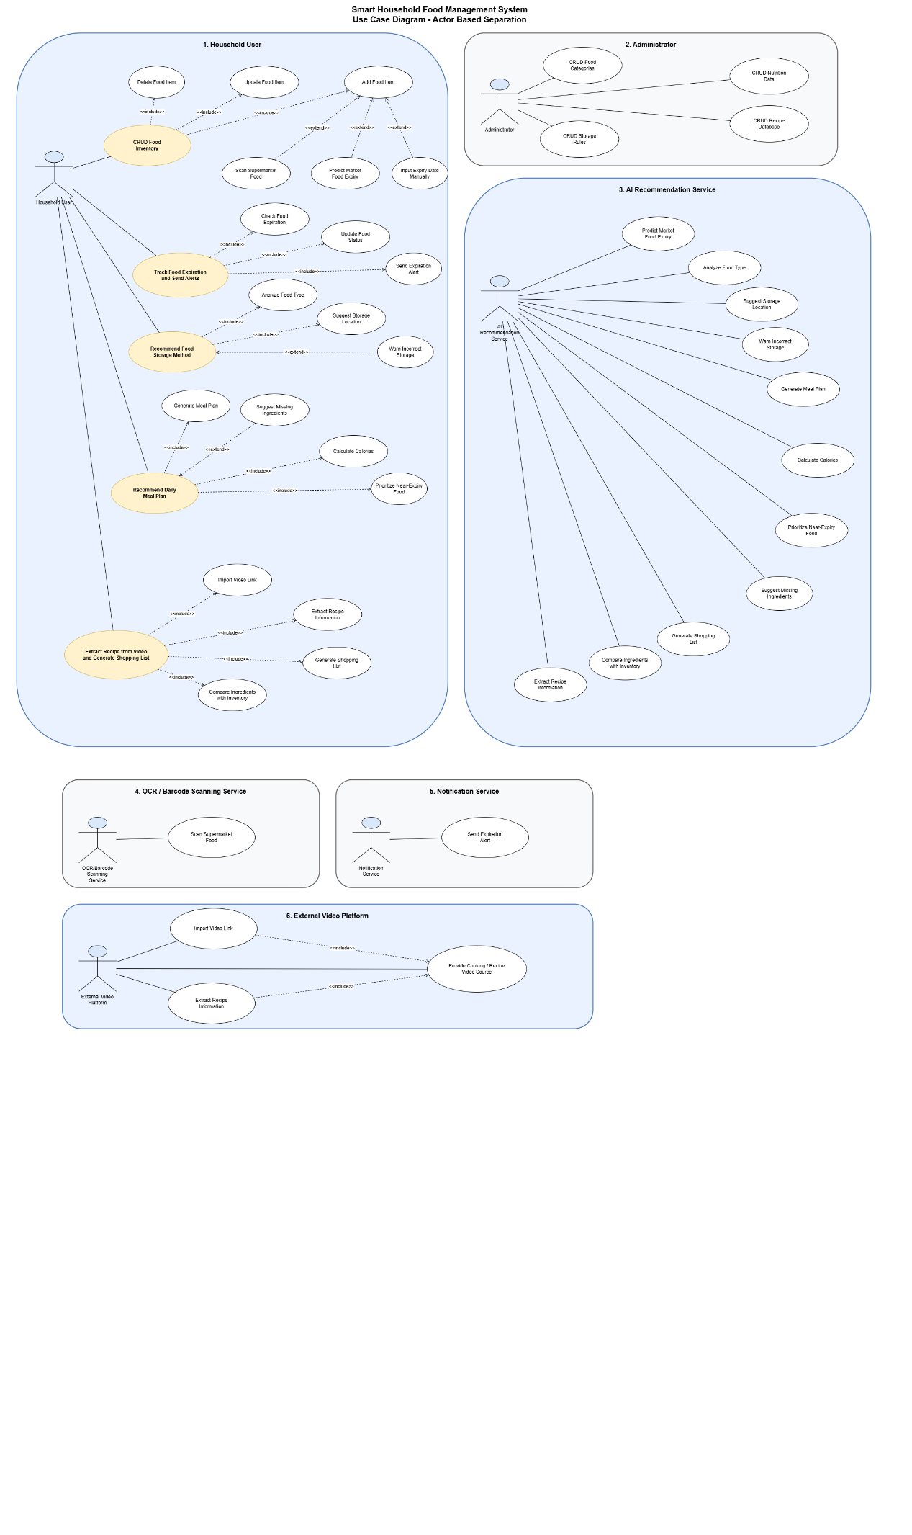
Figure I-2 Overview Use Case Diagram of SHFMS – Actor-Based Separation

b. Descriptions
This part describes the use cases, you can follow the table form as below]
ID | Feature | Use Case | Use Case Description
UC-01 | Register Account | User | User creates a new account to use the system.
UC-02 | Log In Account | User | User logs in to access personal food inventory and meal features.
UC-03 | View Food Inventory | User | User views all food items currently stored in the household inventory.
UC-04 | Add Food Item | User, Scanning Service, AI Recommendation Service | User adds a new food item to the inventory using scanning, AI prediction with food name, quantity, source type, expiry date, and storage location.
UC-05 | Scan Supermarket Food | User, Scanning Service | User scans supermarket food to recognize barcode information or expiration date from the package.
UC-06 | Predict Market Food Expiry | User, AI Recommendation Service | AI estimates the expected expiration date for food bought from traditional markets.
UC-07 | Input Expiry Date Manually | User | User manually enters or edits the expiration date of a food item.
UC-08 | Update Food Item | User | User updates food information such as quantity, storage location, or expiry date.
UC-09 | Delete Food Item | User | User removes a food item from the inventory when it is used, expired, or no longer needed.
UC-10 | View Expiration Status | User | User checks whether food items are safe, near expiry, expired, or need checking.
UC-11 | Receive Expiration Alert | User, Notification Service | User receives alerts when food is near expiry or expired.
UC-12 | View Storage Suggestion | User, AI Recommendation Service | User views recommended storage methods for food items based on food type and storage location.
UC-13 | Generate Daily Meal Plan | User, AI Recommendation Service | User generates meal suggestions based on available food, near-expiry items, preferences, and calorie goals.
UC-14 | Calculate Meal Calories | User, AI Recommendation Service | User views estimated calories for a meal or daily meal plan.
UC-15 | Extract Recipe from Video | User, External Video Platform, AI Recommendation Service | User provides a video link, and the system extracts recipe information from the video.
UC-16 | Create Shopping List | User | User creates a shopping list based on missing ingredients or personal needs.
UC-17 | Add Item to Shopping List | User | User adds missing or needed food items to the shopping list.
UC-18 | Mark Item as Purchased | User | User marks shopping list items as purchased after buying them.
UC-19 | Share Family Shopping List | Premium User, Family Member | Family members synchronize shopping list and inventory changes in real time.
UC-20 | Purchase Premium Plan | User, Payment Gateway | User purchases a premium plan to unlock premium features.
UC-21 | View Nutrition Macro Report | Premium User, AI Recommendation Service | Premium user views protein, carbohydrate, fat, and calorie reports by week or month.
UC-22 | Create Storage Location | Premium User | Premium user creates multiple storage locations such as refrigerator, freezer, and pantry.
UC-23 | Create Food Category | Administrator | Administrator creates a new food category for system classification.
UC-24 | Update Food Category | Administrator | Administrator updates food category information.
UC-25 | Configure Storage Rule | Administrator | Administrator configures storage rules for food categories and storage locations.
UC-26 | Update Nutrition Data | Administrator | Administrator updates calorie and nutrition information used by the system.
UC-27 | Create Recipe | Administrator | Administrator creates sample recipes for meal recommendation.
UC-28 | Update Recipe | Administrator | Administrator updates recipe information, ingredients, steps, and calories.
UC-29 | Review AI-generated Data | Administrator | Administrator reviews AI-generated expiry rules, storage suggestions, or recipe data before they become official system data.

2. Overall Functionalities

2.1 Screens Flow
[This part shows the system screens and the relationship among screens. You can draw the Screens Flow for the system in the form of diagram as below. Please note that beside the normal flat screen, we might have the oval notation for pop-up screen (Import Order) or a screen with multiple information tab (Order Details), etc. You may also use text or background format for different visuality purpose]
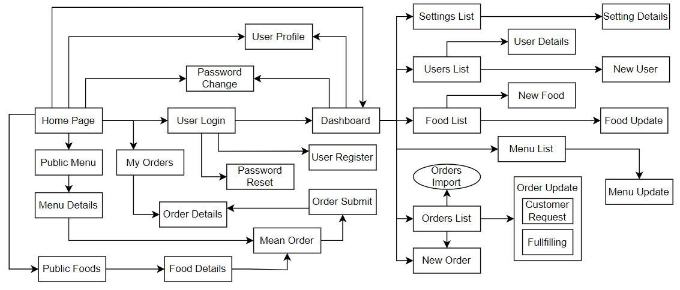

2.2 Screen Descriptions
[Provide the descriptions for the screens in the Screens Flow above]
# | Feature | Screen | Description
1 | Authentication | Login Screen | Allows users to log in using email and password. It also provides forgot password and social login options.
2 | Authentication | Register Screen | Allows new users to create an account by entering full name, email, password, and confirm password.
3 | Authentication | Email Verification Screen | Allows users to enter a 6-digit OTP code to verify their email after registration.
4 | Food Inventory | Home Screen | Displays inventory overview, average freshness, near-expiry food, waste reduction, and food item cards.
5 | Scanning | Scan Screen | Allows users to scan supermarket food or market food using the camera.
6 | AI Prediction | AI Result Screen | Displays recognized food name, confidence score, predicted expiry date, storage suggestion, nutrition information, and suggested meals.
7 | Meal Planning | Meals Screen | Shows daily calorie goal, macro percentage, and meal recommendations based on available food.
8 | Shopping List | Shopping List Screen | Displays food items that users need to buy, grouped by category. Users can mark items as purchased.
9 | User Settings | Setting Screen | Allows users to update profile, notification setting, language, dark mode, backup, and privacy settings.

2.3 Screen Authorization
[Provide the system roles authorization to the system features (down to screens, and event to the screen activities if applicable) in the table form as below – replace Role1, Role2,… with your specific system user role names]
Screen | Role-Name1 | Role-Name2 | Role-Name3 |  | …
Login Screen | X
Register Screen | X
Email Verification Screen | X
Home Screen |  | X | X | X
Scan Screen |  | X | X
AI Result Screen |  | X | X
Meals Screen |  | X | X
Shopping List Screen |  | X | X | X
Setting Screen |  | X | X | X | X
Admin Data Screen |  |  |  |  | X

2.4 Non-UI Functions
[Provide the descriptions for the functions which have no UI (or not screens), i.e batch/cron job, service, API, etc.]
# | Feature | System Function | Description
1 | <<Feature Name>> | <<Function Name1>> | <<Function Name1 Description>>
2 | …

3. System High Level Design

3.1 Database Design
[Provide the tables relationship like example below]

a. Database Schema

b. Table Descriptions
No | Table | Description
01 | <Table name> | <Description of the table>  - Primary keys: <<list of primary key fields>>  - Foreign keys: <<list of foreign key fields>>
02 | <Table name2> | …

3.2 Code Packages
[Provide the package diagram for each sub-system. The content of this section including the overall package diagram, the explanation, package and class naming conventions in each package. Please see the sample & description table format below]
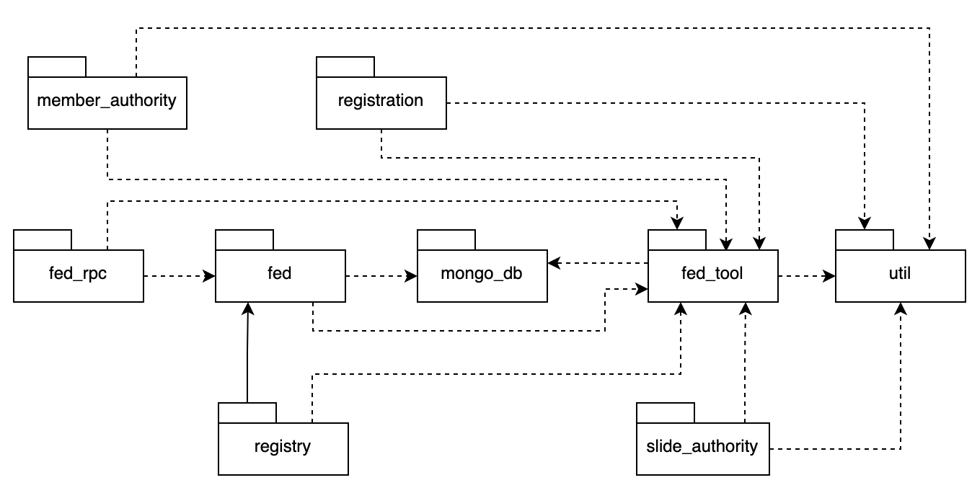
Package descriptions
No | Package | Description
01 | Member_authority | <Description of the package>
02 | registration | <Description of the package>
03 | …

II. Requirement Specifications

UC-01 Register Account
UC ID and Name: | UC-01 Register Account
Created By: | Nguyen Minh Thong | Date Created: | 10/06/2026
Primary Actor: | User | Secondary Actors: | None
Trigger: | User selects the "Register" option on the application.
Description: | This use case allows a new user to create an account by providing personal information, email address, and password. The system validates the information and creates a new account if the email does not already exist.
Preconditions: | PRE-1: User is not logged in.  PRE-2: Registration screen is available.
Postconditions: | POST-1: A new user account is created.  POST-2: User information is stored in the system.
Normal Flow: | 1.0 User opens the registration screen.  1.1 System displays the registration form.  1.2 User enters name, email, password, and confirmation password.  1.3 User clicks the Register button.  1.4 System validates the input information.  1.5 System checks whether the email already exists.  1.6 System creates a new account.  1.7 System displays a registration success message
Alternative Flows: | 1.1 User cancels the registration process and returns to the login screen.  1.2 Email address does not exist in the system and registration continues from step 1.6.
Exceptions: | 1.0.E1 Required fields are empty. System displays validation errors.  1.0.E2 Email format is invalid. System requests the user to enter a valid email.  1.0.E3 Password and confirmation password do not match.  1.0.E4 Email already exists in the system.
Priority: | High – Must Have
Frequency of Use: | Medium
Business Rules: | BR-01 Password Encoding  BR-02 Unique Email Address
Other Information: | The system should respond within 3 seconds.  All user information must be securely stored.  If registration fails unexpectedly, no account record shall be created.
Assumptions: | User has a valid email address.  Internet connection is available.
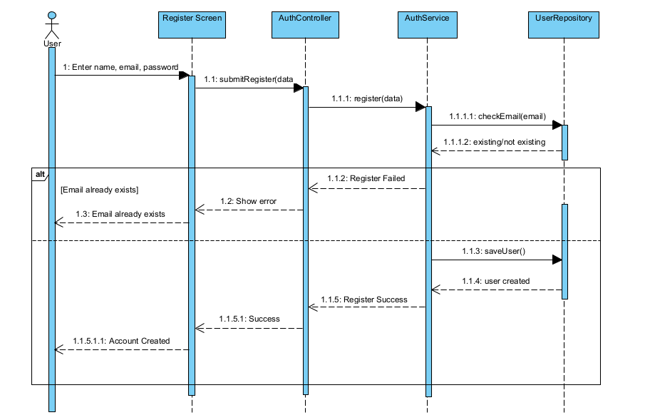

UC-02 Log In Account
UC ID and Name: | UC-02 Log In Account
Created By: | Nguyen Minh Thong | Date Created: | 10/06/2026
Primary Actor: | User | Secondary Actors: | Non
Trigger: | User clicks the Log In button.
Description: | This use case allows a registered user to access the Smart Household Food Management System using a valid email and password.
Preconditions: | PRE-1: User account already exists.  PRE-2: User is not currently logged in.
Postconditions: | POST-1: User is authenticated.  POST-2: User session is created.  POST-3: Home page is displayed.
Normal Flow: | 2.0 User opens the login screen.  2.1 User enters email and password.  2.2 User clicks the Log In button.  2.3 System validates input data.  2.4 System verifies account credentials.  2.5 System creates a user session.  2.6 System displays the home page.
Alternative Flows: | 2.1 User selects Forgot Password and is redirected to password recovery.
Exceptions: | 2.0.E1 Email field is empty.  2.0.E2 Password field is empty.  2.0.E3 Invalid email or password.  2.0.E4 Account has been disabled.
Priority: | High – Must Have
Frequency of Use: | Very High
Business Rules: | BR-01 Password Encoding  BR-03 Authentication Required
Other Information: | The system should complete authentication within 3 seconds.
Assumptions: | The user remembers account credentials.
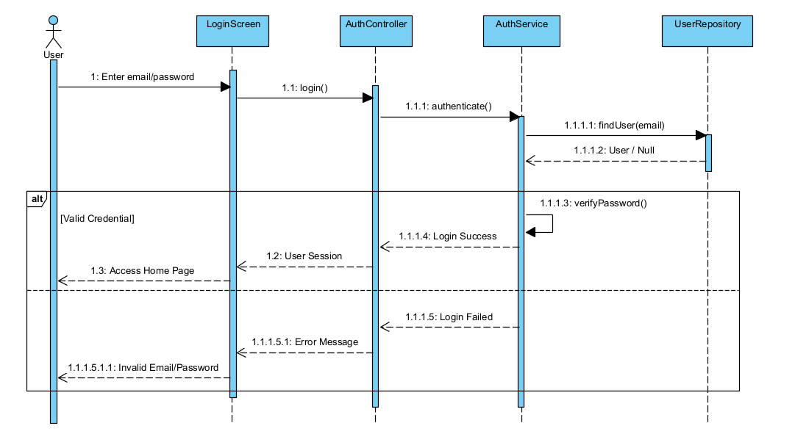

UC-03 View Food Inventory

UC ID and Name: | UC-03 View Food Inventory
Created By: | Nguyen Minh Thong | Date Created: | 10/06/2026
Primary Actor: | User | Secondary Actors: | None
Trigger: | User opens the Inventory page.
Description: | This use case allows users to view all food items stored in their household inventory, including food information, quantity, storage location, expiration date, and status.
Preconditions: | PRE-1: User has logged in successfully.  PRE-2: User account is active.
Postconditions: | POST-1: Food inventory is displayed.  POST-2: Food status information is updated and
Normal Flow: | 3.0 User opens the Inventory screen.  3.1 System retrieves all food items belonging to the user.  3.2 System calculates food status.  3.3 System displays food information.  3.4 User views inventory details.
Alternative Flows: | 3.1 User filters inventory by storage location.  3.2 User searches for a food item by name.  3.3 User sorts food items by expiration date.
Exceptions: | 3.0.E1 Inventory is empty.  3.0.E2 Inventory data cannot be loaded.
Priority: | High – Must Have
Frequency of Use: | Very High
Business Rules: | BR-03 Authentication Required  BR-05 Inventory Consistency
Other Information: | Food status may include Safe, Near Expiry, Expired, or Check Required.
Assumptions: | Food inventory data already exists in the system.

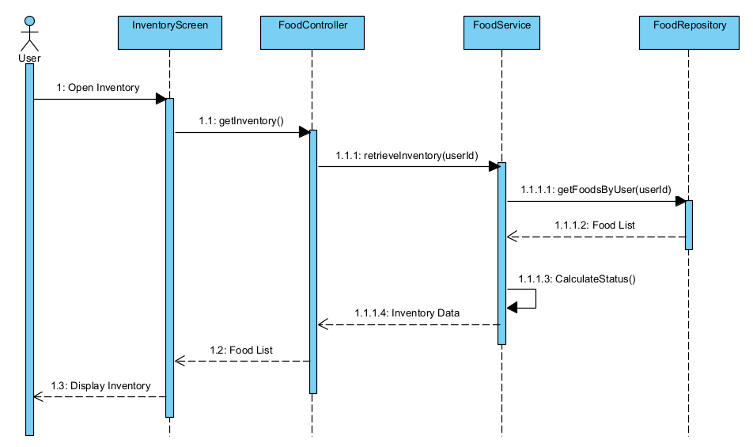

UC-04 Add Food Item
UC ID and Name: | UC-04 Add Food Item
Created By: | ThangTD | Date Created: | June-10, 2026
Primary Actor: | User | Secondary Actors: | Scanning Service,  AI Recommendation Service
Trigger: | The user selects the "Add Food Item" function on the inventory management interface.
Description: | This use case allows the user to add a new food item to their digital inventory. The user can choose to scan a barcode, a receipt, or take a photo of the item. The system coordinates with the Scanning Service and AI Recommendation Service to automatically recognize and predict key details: food name, quantity, source type, expiry date, and storage location. The user reviews, edits if necessary, and confirms to save.
Preconditions: | PRE-1: The user has logged in to the system (BR-03, BR-04).  PRE-2: The user has granted the application permission to access the device's camera.  PRE-3: The system has a stable internet connection to communicate with the external Scanning and AI services.  PRE-4: For free tier users, they must not have exceeded their active asset storage cap (BR-05).
Postconditions: | POST-1: A new food item is successfully created and stored in the inventory database (BR-12).  POST-2: The item is correctly mapped to the user's selected storage location.  POST-3: Food status is automatically calculated (BR-17). If applicable, expiration trackers and real-time push alerts are scheduled (BR-18, BR-36).
Normal Flow: | 4.0.1 The user opens the Inventory Management screen.  4.0.2 The user selects the "Add Food Item" button.  4.0.3 The system displays input options: Scan (Barcode/Receipt/Photo) or Manual Input.  4.0.4 The user selects the Scan option and captures/scans a supermarket food item using the camera.  4.0.5 The Scanning Service processes the barcode or recognizes the expiry date via OCR (BR-20). The system marks the expiry date source as SCANNED (BR-14).  4.0.6 The system references official storage rules first (BR-23). For any gaps, it invokes the AI Recommendation Service (BR-23) to predict remaining metadata (Food Name, Quantity, Unit, Source Type, Expiry Date, and Suggested Storage Location).  4.0.7 The system displays the form pre-populated with these predicted values. AI-generated dates and fields are flagged clearly as an estimated value (BR-15, BR-21).  4.0.8 The user reviews the auto-filled data, makes adjustments if necessary, and submits the form, explicitly confirming the AI-generated or suggested data (BR-22).  4.0.9 The system validates the data against input thresholds (BR-12, BR-13, BR-15, BR-16).  4.0.10 The system calculates the item's initial condition layer (Safe, Near Expiry, Expired, Need Check) (BR-17, BR-18).  4.0.11 The system saves the new food item to the database, flashes a success confirmation, and updates the inventory view.
Alternative Flows: | 1-AF: User Chooses Manual Input / Scanning Failure Fallback  At step 4.0.3, the user selects "Manual Input" OR at step 4.0.5, the barcode/OCR scan fails to read the product (BR-20).  The system opens an empty "Add Food Item" form.  The user manually keys in all required properties. The system flags the expiry date source attribute as MANUAL (BR-14).  The flow resumes from step 4.0.8 of the Normal Flow.  2-AF: Traditional Market Food Input with AI Expiration Prediction  At step 4.0.4, the user scans or manually identifies an item purchased from a traditional open market.  The user selects or the system flags the Source Type as MARKET (BR-13).  The system invokes the AI Recommendation Service to estimate an expiration timeline and ideal storage path (BR-21).  The system sets the expiry date source attribute to AI_PREDICTED (BR-14) and renders the date on-screen labeled as an "Estimated Value" (BR-15, BR-21).  The flow resumes from step 4.0.8 of the Normal Flow.
Exceptions: | 1-EX: Smart Services Unavailable / Connection TimeoutAt step  4.0.5 or 4.0.6, if connection to the Scanning or AI Service drops, or the APIs throw a timeout error.  The system displays an overlay notification: "Smart recognition service is currently unavailable. Please try again or switch to manual entry.  "The system automatically safely degrades to an empty form layout, routing the user into 1-AF (Manual Input).  2-EX: Invalid Input Parameters Detected  -At step 4.0.9, if the validation module catches non-compliant data fields:  Scenario A: The designated Expiry Date is chronologically earlier than the Purchase Date (BR-15).  Scenario B: The Quantity field evaluates to less than or equal to zero ($\le 0$), or contains an unrecognized unit string (BR-16).  -The system halts the submission track, highlights the violating field components, and prompts an inline warning notification.  -The form state remains preserved, keeping fields open for user modifications.  3-EX: Mismatched/Unsuitable Storage Location Profile  At step 4.0.9, the validation engine discovers that the user is trying to place a highly perishable item into an incompatible zone (e.g., storing fresh milk in a warm room-temperature pantry cupboard).  The system triggers a contextual warning block (BR-24): "Warning: This storage location may not be suitable for this type of food item. Are you sure you want to proceed?  The user can choose to bypass the warning and save anyway, or cancel to change the storage location.
Priority: | High , Must Have
Frequency of Use: | Very Frequent (Multiple times daily, whenever the user buys groceries, cooks, or restocks their kitchen).
Business Rules: | BR-03 / BR-04: Restricts access to authorized logged-in users.  BR-05 / BR-06: Enforces storage location limits based on the user's current subscription level.  BR-12: Mandates inclusion of Food Name, Quantity, Unit, Source Type, Purchase Date, Expiry Date, and Storage Location.  BR-13: Constrains source options exclusively to SUPERMARKET or MARKET.  BR-14 / BR-15: Drives expiry date validation rules and source categorization tracking (SCANNED, AI_PREDICTED, MANUAL).  BR-16: Rejects quantities $\le 0$ and binds unit types to standard measures ($g$, $kg$, $ml$, etc.).  BR-17 / BR-18: Automates status workflows for freshness categorization rules.  BR-20 / BR-21 / BR-22: Dictates scanning OCR mechanics, traditional market AI workarounds, and user validation override demands.  BR-23 / BR-24: Configures cascading lookup priority rules for storage configurations and structural environment hazard warnings.  BR-36: Requires active push notification permission hooks before scheduling expiration alert pathways.
Other Information:
Assumptions: | The client device maintains local clock parameters synchronized to network standard time zones to prevent purchase date and expiry date differential computation errors.  The AI Recommendation Service model parameters are continuously updated with localized grocery item profiles and standard household shelf-life data structures

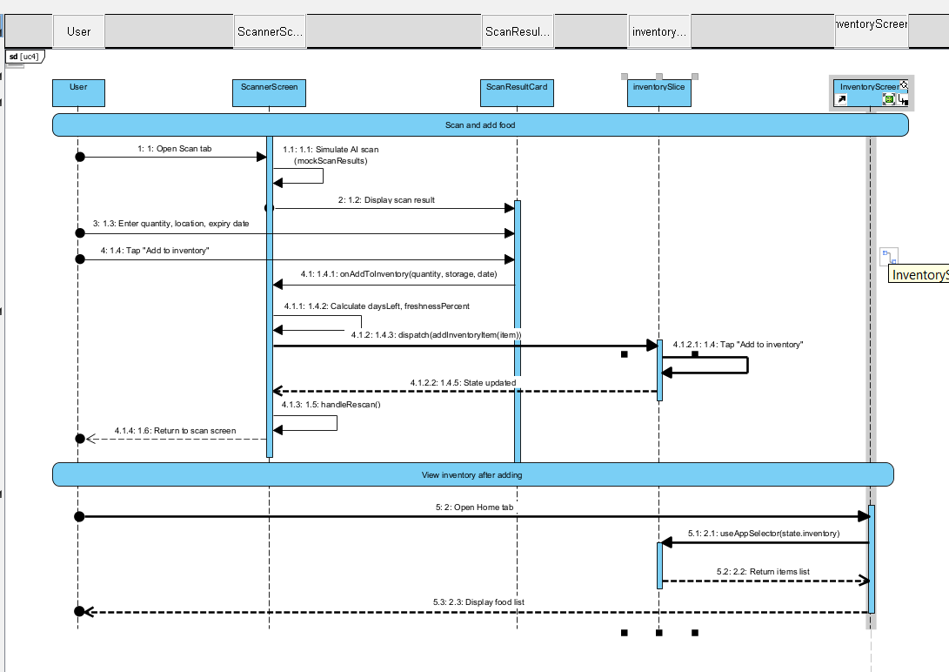

UC-05 Scan Supermarket Food
UC ID and Name: | UC-05 Scan Supermarket Food
Created By: | ThangTD | Date Created: | June-10, 2026
Primary Actor: | User | Secondary Actors: | Scanning Service
Trigger: | The user selects the "Scan" option while adding or checking a food item.
Description: | This use case describes the technical and behavioral steps for capturing food data from supermarket products. The user points their device camera at a product package. The system uses the Scanning Service to read barcode information (cross-referencing the global product database) or execute Optical Character Recognition (OCR) to detect printed expiration dates. The extracted text and product details are then mapped onto the data form.
Preconditions: | PRE-1: The user has logged in to the system and is authorized (BR-03, BR-04).  PRE-2: The user has granted camera hardware access permissions to the application.  PRE-3: The device has an active network connection to communicate with the external product and scanning registries.
Postconditions: | POST-1: Barcode string data or text-based expiry strings are successfully processed.  POST-2: Recognized attributes are sent back to populate the inventory form with the date source explicitly flagged as SCANNED (BR-14).
Normal Flow: | 5.0.1 The user activates the scanner view inside the application.  5.0.2 The system initializes the device camera overlay stream.  5.0.3 The user aligns the product package barcode or printed expiration text within the scanning viewport (BR-20).  5.0.4 The Scanning Service detects, focuses, and captures the image frames.  5.0.5 The system extracts the data stream via two concurrent tracks:  Track A: Decodes the global barcode matrix to extract the product profile (Food Name, Brand, Unit Type, Base Category).  Track B: Parses the raw package text fields using an OCR engine to isolate the manufacturer's expiration date code.  5.0.6 The system sets the metadata source parameter of the expiration date to SCANNED (BR-14).  5.0.7 The system returns the parsed values to the active entry form, prompting the user to review and confirm the scanned outputs (BR-22).
Alternative Flows: | 1-AF: Barcode Matches but OCR Expiration Date Fails to Read  At step 5.0.5, the scanning layer successfully recognizes the barcode profile but the text-based expiration stamp is smudged, torn, or unreadable by the OCR engine.  The system fills in the product profile parameters (Name, Unit, Category) but leaves the Expiry Date input field blank.  The system prompts the user with an inline tip: "Product found! Please select or enter the expiration date manually."  The user manually inputs the date, and the system dynamically updates that field’s source attribute from SCANNED to MANUAL (BR-14).  The flow resumes from step 5.0.7 of the Normal Flow.
Exceptions: | 1-EX: Full Scanning Failure (Unrecognized Barcode and OCR Timeout)  At step 5.0.5, the product barcode is missing from the global catalog databases, and the OCR engine fails to isolate any structured calendar dates within the frame area (BR-20).  The system plays a low-tone audio/haptic error cue and presents a prompt modal: "Could not recognize product info. Would you like to try again or switch to manual input?"  If the user chooses "Manual Input", the system closes the camera frame and redirects them directly to a blank entry structure (1-AF inside UC-04).  2-EX: Invalid Date String Scanned (OCR Translation Anomaly)  At step 5.0.5, the OCR engine misreads package art text as a date, resulting in an impossible temporal format or an expiration matrix chronologically older than the system's current calendar baseline purchase date (BR-15).  The validation engine flags the input error before rendering it onto the user UI.  The system discards the bad date value, alerts the user to check the package text, and places focus back on the live scanning frame.
Priority: | High, Must Have
Frequency of Use: | Very Frequent (Every time a user returns from a grocery store trip with commercial, barcoded inventory).
Business Rules: | BR-14: Binds the internal date source history state tag explicitly to SCANNED upon successful extraction.  BR-15: Guarantees that even structural OCR extractions are sanity-checked against the current calendar purchase date.  BR-20: Dictates the system must support barcode scanning or OCR expiry date recognition for commercial supermarket items, with graceful degradation to manual handling paths.  BR-22: Dictates that all automation outputs, including scanned metrics, require explicit user interaction confirmation before freezing into permanent cloud history states.  BR-23 / BR-24: Influences downstream automation. If the barcode maps to a known item category, it pulls official storage rules over generic AI suggestions.  BR-34: Protects the underlying database architecture—users scan products to append items to their individual profile list, but they cannot alter master global catalog entries (which remain locked to Admins).
Other Information:
Assumptions: | The supermarket packaging has clear, legible barcode elements using standard commercial configurations (UPC, EAN-13, QR codes).  The environmental lighting is sufficient for the hardware sensor lens to capture clear frames.
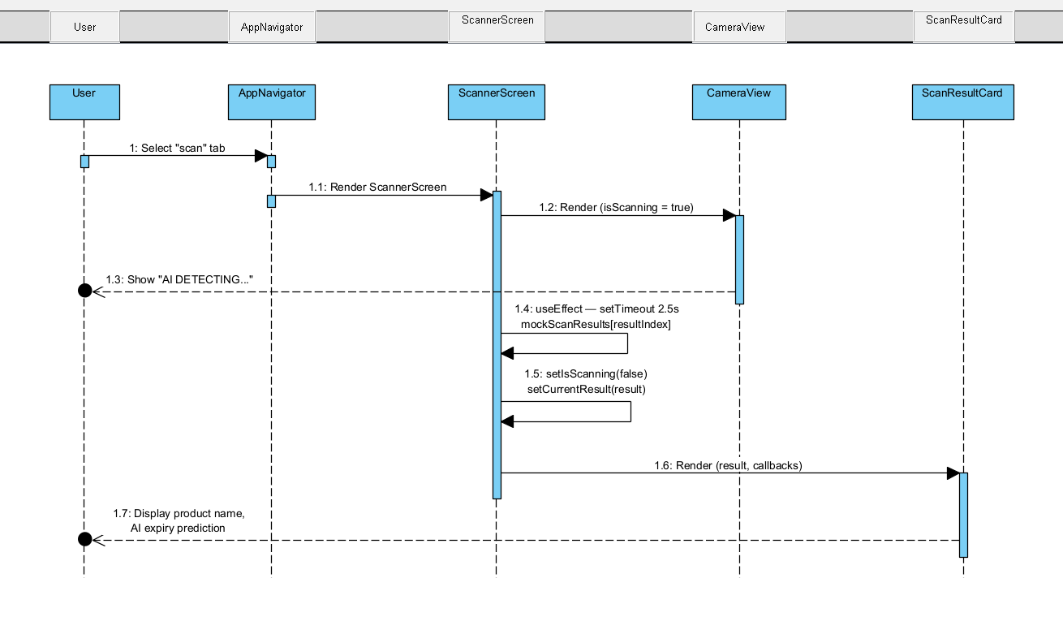

UC-06 Predict Market Food Expiry
UC ID and Name: | UC-06 Predict Market Food Expiry
Created By: | ThangTD | Date Created: | June-10, 2026
Primary Actor: | User | Secondary Actors: | AI Recommendation Service
Trigger: | The user sets or changes the food item's Source Type to MARKET within the inventory form.
Description: | This use case covers the step-by-step process where the system utilizes the AI Recommendation Service to predict and calculate a reasonable expiration timeline for loose, unpackaged, or fresh food items typically bought from traditional open markets (e.g., fresh vegetables, wet-market meat, loose seafood) which naturally lack commercial barcodes or printed expiration stamps.
Preconditions: | PRE-1: The user has logged in to the system and is on the add/edit item form layout (BR-03, BR-04).  PRE-2: The user has provided a recognizable Food Name or Category string (either via text typing or raw image recognition).  PRE-3: The system has an active internet connection to communicate with the cloud-based AI service engines.
Postconditions: | POST-1: The system successfully computes an optimized expiration timeframe estimate based on food science baselines.  POST-2: The Expiry Date input field is pre-filled, visually labeled as an estimation, and its tracking flag is saved as AI_PREDICTED (BR-14, BR-15).
Normal Flow: | 6.0.1 The user sets the product’s Source Type selector to MARKET (BR-13).  6.0.2 The system checks for existing textual parameters in the "Food Name" or "Category" fields.  6.0.3 The system sends an asynchronous request payload containing the food details, current purchase date, and the selected storage zone to the AI Recommendation Service.  6.0.4 The system evaluates official storage rule lookups first to establish a foundation profile (BR-23).  6.0.5 The AI Recommendation Service processes the payload against food preservation shelf-life matrices and returns a fallback expiration date estimate (BR-23).  6.0.6 The system sets the metadata tracking property of the Expiry Date field to AI_PREDICTED (BR-14).  6.0.7 The system populates the Expiry Date form element and appends a distinct "Estimated/Suggested" UI label component next to it (BR-15, BR-21).  6.0.8 The user reviews this date value, edits it if their real-world inspection suggests otherwise, and taps confirm (BR-21, BR-22).
Alternative Flows: | 1-AF: The User Changes the Target Storage Location Mid-Process  At step 6.0.7, the system suggests an expiry date based on a "Fridge (Chilled)" environment. The user notices this and changes the storage location selector element to "Freezer".  The system detects the configuration change event.  The system instantly triggers a re-calculation pipeline back to step 6.0.3 with the updated storage location parameter.  The AI Recommendation Service updates the timeline dynamically (e.g., extending a beef item's shelf life from 3 days to 3 months).  The flow resumes from step 6.0.6 of the Normal Flow.
Exceptions: | 1-EX: Ambiguous or Unrecognized Food Text Input  At step 6.0.2, the user types an ambiguous word, slang string, or an unclassified ingredient phrase that the AI database cannot match to an organic shelf-life index.  The system skips the auto-prediction engine loop entirely.  The system leaves the Expiry Date entry element empty, clears any active estimate badges, and displays a micro-text indicator: "Unrecognized food type. Please specify the expiration timeline manually."  The system switches the metadata field flag to MANUAL (BR-14) as soon as the user selects a calendar date.  2-EX: Unsafe Storage Parameter Combination Detected  At step 6.0.5, the AI engine detects that the user's manual selection for the item's destination storage zone creates a food safety hazard based on standard parameters (e.g., placing raw market pork directly into a room-temperature ambient pantry shelf).  The system passes back an error payload along with the expiration calculation.  The system displays a highly visible warning overlay on the storage selection module (BR-24): "Warning: Storing fresh meat in the pantry may lead to rapid spoilage. Consider moving this item to the Fridge or Freezer."  The form state remains active, allowing the user to either accept the structural risk or swap to a recommended location alternative.
Priority: | High, Must Have
Frequency of Use: | Very Frequent (Every time a user logs fresh meat, fish, herbs, or local open-market organic purchases).
Business Rules: | BR-13: Requires items to route specifically through either SUPERMARKET or MARKET structural logic pipelines.  BR-14: Forces the tracking model metadata status column to preserve the AI_PREDICTED signature tag.  BR-15 / BR-21: Guarantees that any prediction values are visually isolated from definitive manufacturer stamps via an "Estimated Value" label indicator layer on the UI, and preserves full manual field edit capabilities.  BR-22: Assures that AI-generated calculation assets do not lock into permanent system databases until the primary actor purposefully signs off or edits the parameters.  BR-23: Establishes data logic execution hierarchy: hardcoded official storage rules take execution precedence, with the machine learning AI acting as an active fallback layer.  BR-24: Activates smart environment checks to push immediate ui warning cues if a user overrides basic safety conditions during open-market manual entry.
Other Information:
Assumptions: | The user types food descriptions using understandable standard language (e.g., "Salmon", "Spinach", "Chicken Breast").  The current system calendar state is accurate to calculate delta values for expiration dates relative to the active purchase date.
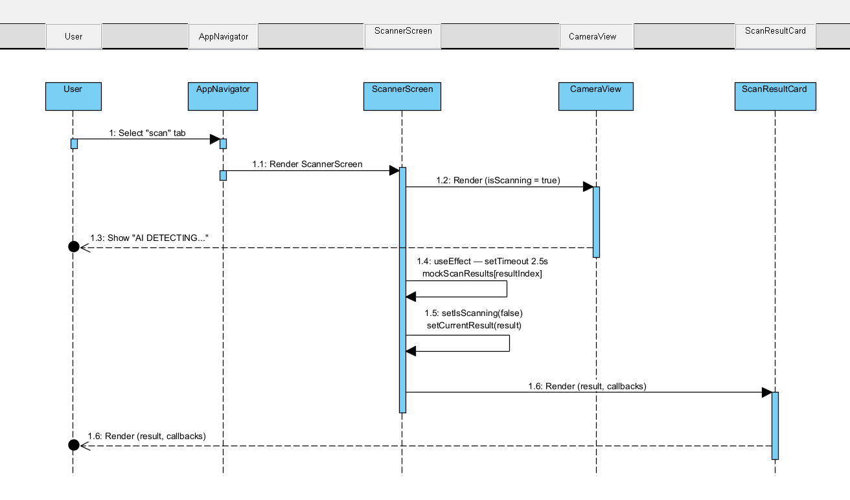

UC-07 Input Expiry Date Manually
UC ID and Name: | UC-07 Input Expiry Date Manually
Created By: | ThangT | Date Created: | June-10, 2026
Primary Actor: | User | Secondary Actors:
Trigger: | The user taps the expiration date input field directly, or the system falls back to manual input due to a scanning/AI failure.
Description: | This use case describes the process where the user manually types or selects an expiration date for a food item using a calendar date-picker tool. This mechanism is utilized when entering non-barcoded items, correcting automated scanner misreads, overriding AI predictions, or completing a form after an automated service fails.
Preconditions: | PRE-1: The user has logged in to the system and is on an active add or edit food item form (BR-03, BR-04).  PRE-2: The user has already specified or default-populated a "Purchase Date" for the item.
Postconditions: | POST-1: The custom expiration date is successfully bound to the item's form state.  POST-2: The metadata source tracking property for the expiry date is explicitly set to MANUAL (BR-14).  POST-3: Any existing automated evaluation state labels (such as "AI Estimated") are cleared or replaced.
Normal Flow: | 7.0.1 The user taps on the "Expiry Date" field within the food entry/edit form.  7.0.2 The system launches an interactive calendar UI date-picker widget.  7.0.3 The user navigates the widget and selects a specific calendar day, month, and year.  7.0.4 The user confirms their selection inside the widget.  7.0.5 The system validates the manually selected date against chronological business logic criteria (BR-15).  7.0.6 The system sets the internal metadata tracking property of the Expiry Date to MANUAL (BR-14).  7.0.7 The system populates the text field with the chosen date format and removes any prior automated estimate badge configurations.  7.0.8 The user submits the parent form to finalize the database entry sequence (BR-22).
Alternative Flows: | 1-AF: User Overrides an Existing AI or Scanned Value  At step 7.0.1, the "Expiry Date" field already contains an auto-populated date string generated via a previous scanning operation (UC-05) or AI inference (UC-06).  The user notices a discrepancy and manually taps the date entry element to alter it.  The system displays the calendar picker initialized on the previously predicted date.  The user selects a new, correct date and confirms.  The system strips away the AI_PREDICTED or SCANNED tracking flag, replacing it with the MANUAL tag (BR-14).  The flow resumes from step 7.0.5 of the Normal Flow.
Exceptions: | 1-EX: Expiry Date Prior to Purchase Date (Chronological Violation)  At step 7.0.5, the validation engine detects that the user's manually designated expiration date occurs chronologically earlier than the item's assigned purchase date (BR-15).  The system rejects the input configuration, prevents form submission, and outlines the date-picker boundaries in an error state.  The system displays an inline error warning: "Invalid Date: Expiration date cannot be earlier than the purchase date."  The user must pick a valid date to clear the exception state.
Priority: | High , Must Have
Frequency of Use: | Very Frequent (Every time a user inputs home-cooked meals, processed items without legible packaging dates, or chooses to correct smart automated data entries).
Business Rules: | BR-12: Ensures that an expiration date remains a strictly required, non-nullable data property before a food object can be committed to the cloud database.  BR-14: Dictates that the source state attribute changes to MANUAL whenever a user explicitly keys in or manually overrides a timeline field.  BR-15: Drives the strict chronological validation boundary checker, enforcing that Expiry Date $\ge$ Purchase Date.  BR-22: Affirms that any structural manual user input choices serve as the official user confirmation step needed to register the item parameters.
Other Information:
Assumptions: | The device's regional settings do not distort date/time synchronization formatting strings ($DD/MM/YYYY$ vs $MM/DD/YYYY$) across different hardware profiles.
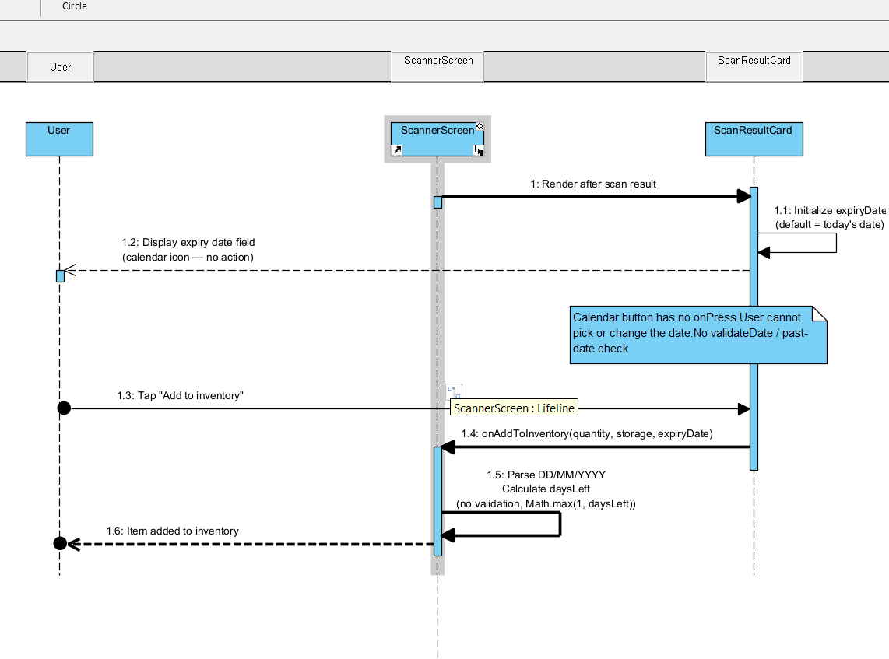

UC-08 Update Food Item
UC ID and Name: | UC-08 Update Food Item
Created By: | Nguyen Minh Thong | Date Created: | 10/06/2026
Primary Actor: | User | Secondary Actors: | None
Trigger: | User selects a food item and clicks Edit.
Description: | This use case allows users to modify food information such as quantity, storage location, expiration date, and notes.
Preconditions: | PRE-1: User is logged in.  PRE-2: Food item exists.  PRE-3: User owns the selected food item.
Postconditions: | POST-1: Food information is updated.  POST-2: Inventory displays the latest information.
Normal Flow: | 8.0 User selects a food item.  8.1 System displays food details.  8.2 User edits food information.  8.3 User clicks Save.  8.4 System validates entered data.  8.5 System updates the food item.  8.6 System displays update success message.
Alternative Flows: | 8.1 User cancels the editing process.  8.2 System recalculates food status after updating expiration date.
Exceptions: | 8.0.E1 Food item does not exist.  8.0.E2 Invalid expiration date.  8.0.E3 Invalid quantity value.  8.0.E4 Update operation fails.
Priority: | High – Must Have
Frequency of Use: | High
Business Rules: | BR-04 Ownership Validation  BR-05 Inventory Consistency
Other Information: | Food status should be refreshed immediately after update.
Assumptions: | User has permission to modify the selected food item.

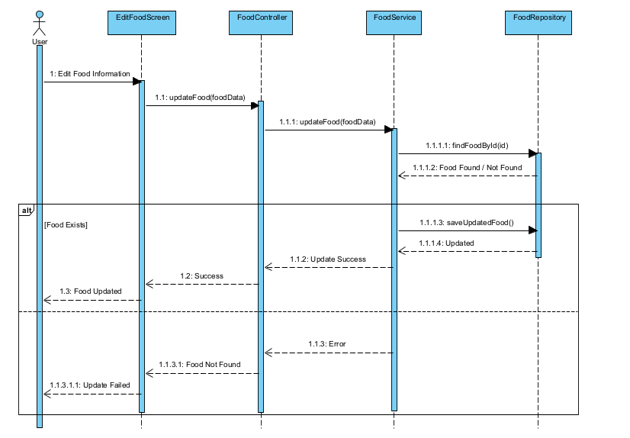

UC-08 Update Food Item

UC-09 Delete Food Item
UC ID and Name: | UC-09 Delete Food Item
Created By: | Nguyen Minh Thong | Date Created: | 10/06/2026
Primary Actor: | User | Secondary Actors: | None
Trigger: | User clicks the Delete button on a food item.
Description: | This use case allows users to remove a food item from their inventory when the item is consumed, discarded, or added by mistake.
Preconditions: | PRE-1: User is logged in.  PRE-2: Food item exists.  PRE-3: User owns the selected food item.
Postconditions: | POST-1: Food item is removed from inventory.  POST-2: Inventory information is updated.
Normal Flow: | 9.0 User selects a food item.  9.1 User clicks Delete.  9.2 System displays confirmation dialog.  9.3 User confirms deletion.  9.4 System removes the food item.  9.5 System updates inventory.  9.6 System displays deletion success message.
Alternative Flows: | 9.1 User cancels deletion.  9.2 System returns to inventory screen without changes.
Exceptions: | 9.0.E1 Food item does not exist.  9.0.E2 User does not have permission to delete the item.  9.0.E3 Deletion process fails.
Priority: | High – Must Have
Frequency of Use: | Medium
Business Rules: | BR-04 Ownership Validation  BR-05 Inventory Consistency
Other Information: | Deleted food items cannot be restored unless backup functionality is implemented.
Assumptions: | User intentionally chooses to delete the food item.
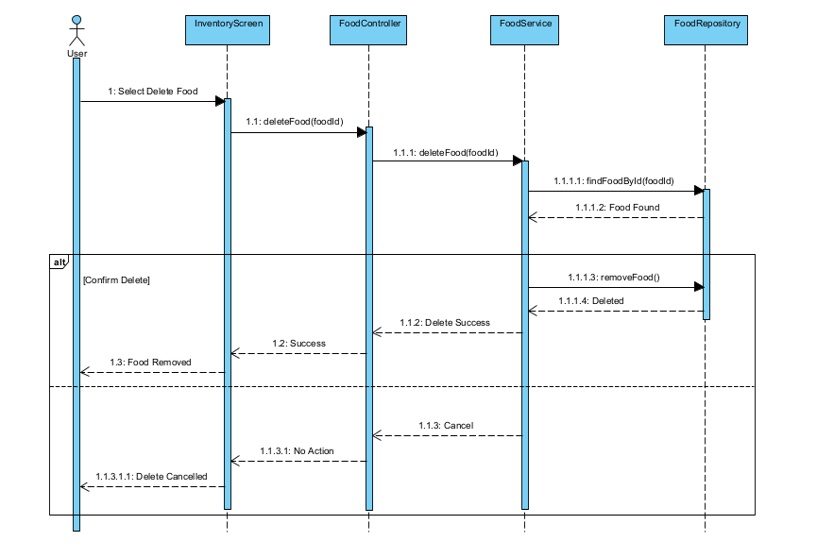

UC-10 View Expiration Status
UC ID and Name: | UC-10 View Expiration Status
Created By: | Le Dinh Nhat Nam | Date Created: | June-10, 2026
Primary Actor: | User | Secondary Actors: | None
Trigger: | The user navigates to the Inventory or Expiration Tracking screen in the app.
Description: | This use case allows the user to view a categorized list of their food items based on their expiration status: Safe, Near Expiry, Expired, or Need Check
Preconditions: | PRE-1: The user has logged in to the system (BR-03).<br>  PRE-2: There are food items stored in the user's inventory
Postconditions: | POST-1: The user views the correctly categorized expiration status of food items.
Normal Flow: | 10.0.1 The user opens the Expiration Tracking / Inventory screen.  10.0.2 The system retrieves all active food items from the user's inventory.  10.0.3 The system calculates the expiration status for each item by comparing the Expiry Date with the current date (BR-17).  10.0.4 The system groups items that are close to their expiry date (e.g., 1-3 days) into the "Near Expiry" category (BR-18).  10.0.5 The system displays the categorized list of food items to the user.
Alternative Flows: | 1-AF: Empty Inventory  At step 10.0.2, if the system finds no food items, it displays a message: "Your inventory is empty. Add food items to track their expiration status."
Exceptions: | 1-EX: Database Connection Error  If the system fails to retrieve data, it displays an error message and suggests the user to pull to refresh.
Priority: | High, Must Have
Frequency of Use: | Very Frequent (Daily usage)
Business Rules: | BR-03 (Authentication Required),  BR-17 (Food Status Calculation),  BR-18 (Near-expiry Rule)
Other Information: | The list should be visually color-coded (e.g., Red for Expired, Yellow for Near Expiry, Green for Safe).
Assumptions: | The device's date and time are correctly synced.
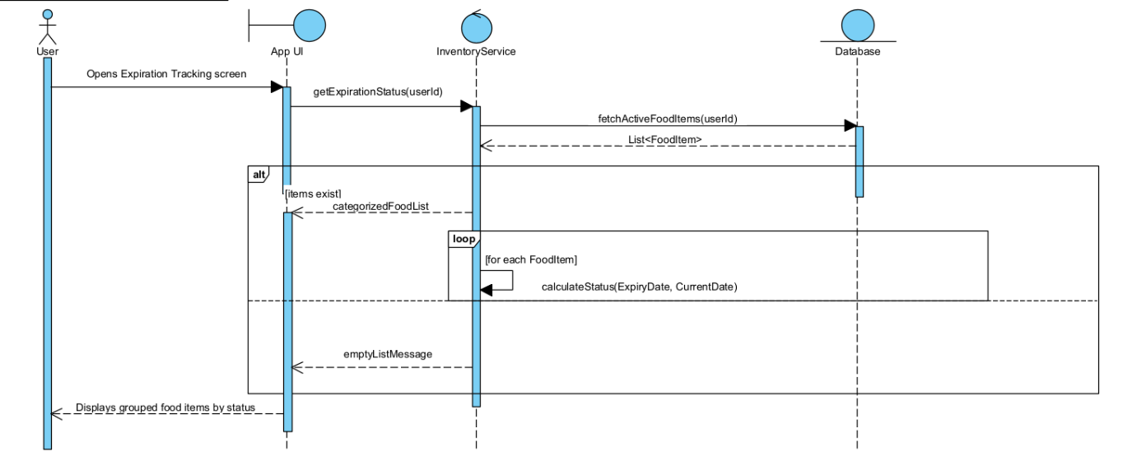

UC-11 Receive Expiration Alert

UC ID and Name: | UC-11 Receive Expiration Alert
Created By: | Le Dinh Nhat Nam | Date Created: | June-10, 2026
Primary Actor: | User | Secondary Actors: | Notification Service
Trigger: | The system's daily background cron job executes, or a food item transitions into "Near Expiry" or "Expired" status.
Description: | The system automatically checks the inventory and sends a push notification to alert the user about food items that are near expiry or have expired to prevent food waste
Preconditions: | POST-1: A push notification is sent to the user's device.  POST-2: The alert is saved in the Notification History (BR-37).
Postconditions: | POST-1: A push notification is sent to the user's device.  POST-2: The alert is saved in the Notification History (BR-37).
Normal Flow: | 11.0.1 The Expiration Checking Cron Job runs automatically at a scheduled time.  11.0.2 The system identifies food items that match the "Near Expiry" (BR-18) or "Expired" criteria.  11.0.3 The system verifies if the user has enabled push notifications (BR-36).  11.0.4 The system prepares the notification payload and sends it to the Notification Service.  11.0.5 The Notification Service delivers the push alert to the user's device.  11.0.6 The system stores the notification record in the database's Notification History (BR-37).  11.0.7 The user taps the notification and is redirected to the Expiration Status screen (UC-10).
Alternative Flows: | 1-AF: Notification Permission Denied  At step 11.0.3, if the user has disabled notifications, the system skips step 11.0.4 and 11.0.5, but still executes step 11.0.6 (saving to Notification History so they can read it in the app) (BR-37).
Exceptions: | 1-EX: Notification Service Failure  At step 11.0.5, if the 3rd-party Notification Service is down, the system logs the failure but successfully saves the alert to the in-app history (BR-37)
Priority: | High, Must Have
Frequency of Use: | Daily (System triggered)
Business Rules: | BR-17 (Food Status Calculation),  BR-18 (Near-expiry Rule),  BR-36 (Notification Permission),  BR-37 (Notification History).
Other Information: | Alerts should be aggregated (e.g., "You have 3 items expiring soon") rather than sending 3 separate push notifications.
Assumptions: | The device has an active internet connection to receive push notifications.
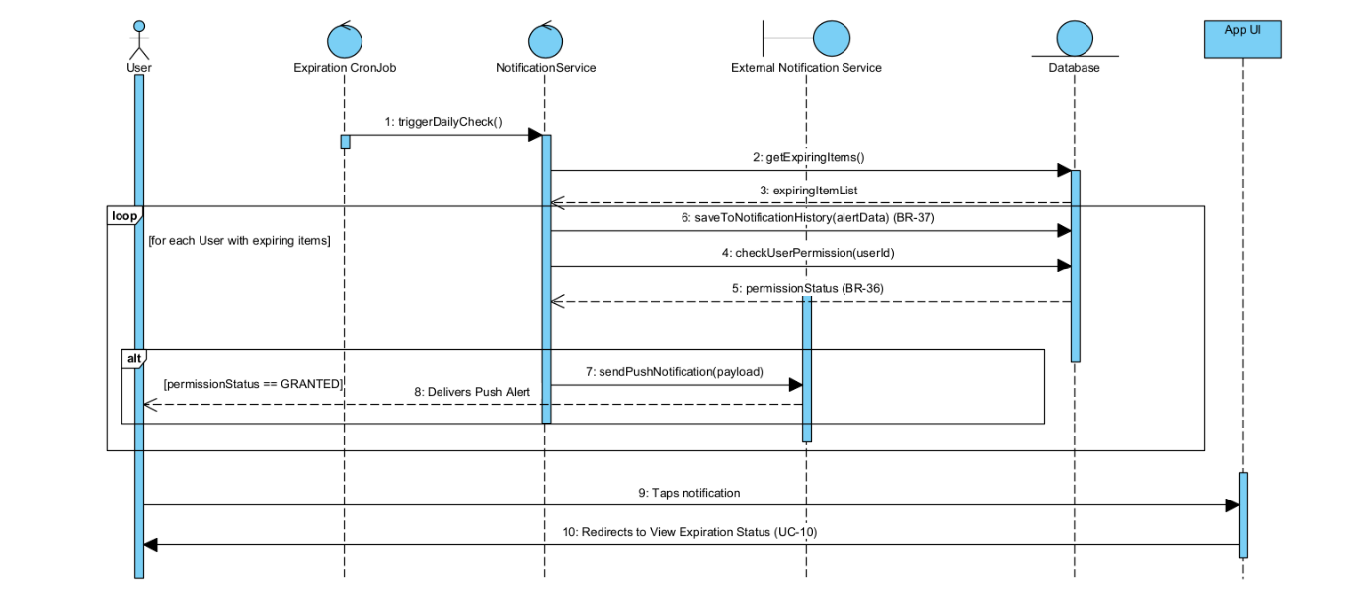

UC-12 View Storage Suggestion

UC ID and Name: | UC-12 View Storage Suggestion
Created By: | Le Dinh Nhat Nam | Date Created: | June-10, 2026
Primary Actor: | User | Secondary Actors: | AI Recommendation Service
Trigger: | The user views food details or adds a new food item and checks storage instructions.
Description: | The system provides recommended storage methods for a specific food item based on its category and intended storage location. It also warns users if the current location is unsuitable
Preconditions: | PRE-1: The user is logged in (BR-03).  PRE-2: The food item has a designated category and source type.
Postconditions: | POST-1: Storage suggestions and any applicable warnings are displayed to the user.
Normal Flow: | 12.0.1 The user requests to view details/storage suggestions for a food item.  12.0.2 The system looks up official storage rules in the database based on the food category (BR-23).  12.0.3 The system finds matching official rules and displays the recommended storage method and duration.  12.0.4 The system compares the suggested storage location with the user's actual/selected storage location.  12.0.5 If there is a severe mismatch (e.g., storing raw meat in a pantry), the system displays an incorrect storage warning (BR-24).
Alternative Flows: | 1-AF: No Official Rule Found - AI Fallback  At step 12.0.2, if no official rule exists for the item, the system sends a request to the AI Recommendation Service (BR-23).  The AI service returns an estimated storage suggestion.  The system displays this suggestion clearly marked as "AI-Generated/Estimated". The flow resumes at 12.0.4.
Exceptions: | 1-EX: AI Service Unavailable  If no official rule is found and the AI Service fails to respond, the system displays a default message: "No specific storage suggestions available at this time."
Priority: | Medium, Should Have
Frequency of Use: | Frequent (When organizing inventory)
Business Rules: | BR-23 (Storage Rule Priority),  BR-24 (Incorrect Storage Warning)
Other Information: | Suggestions should include practical tips (e.g., "Keep away from apples").
Assumptions: | Official storage rules have been properly configured by the Administrator (UC-25).
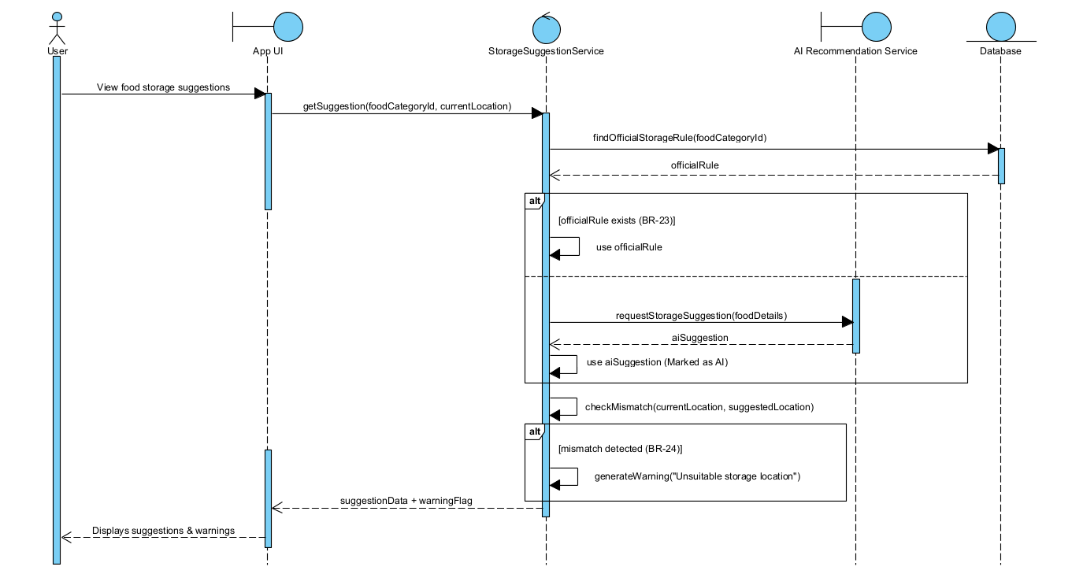

UC-13: Generate Daily Meal Plan

Use Case Specification
Use Case ID and Name: | UC-13 - Generate Daily Meal Plan
Created By: | Nguyen Tien Dung | Date Created: | June-10, 2026
Primary Actor: | User | Secondary Actors: | AI Recommendation Service
Trigger: | User navigates to the Meal Plan section and selects 'Generate Daily Meal Plan'.
Description: | The system generates a set of daily meal suggestions based on available food items in the user's inventory, prioritizing near-expiry items, and considering the user's preferences, dietary goals, and calorie targets. The AI Recommendation Service produces the suggestions, which the user can review and accept or regenerate.
Preconditions: | PRE-1: User is authenticated and logged in.  PRE-2: User has at least one food item in the inventory.  PRE-3: User's preference profile (allergies, dietary goals, calorie target) is accessible (may be default if not set).
Post–conditions: | POST-1: A daily meal plan is displayed to the user.  POST-2: Estimated calorie totals for the plan are shown.  POST-3: Near-expiry items used in the meal plan are highlighted.
Normal Flow: | 13.0.1 - User opens the Meal Plan section and clicks 'Generate Daily Meal Plan'.  13.0.2 - System retrieves all available food items and identifies near-expiry items from the inventory.  13.0.3 - System retrieves user preferences (allergies, disliked foods, calorie target, dietary goals).  13.0.4 - System sends food list and preferences to the AI Recommendation Service.  13.0.5 - AI Recommendation Service generates meal suggestions prioritizing near-expiry food and matching preferences.  13.0.6 - System displays the generated daily meal plan (breakfast, lunch, dinner, optional snacks) with estimated calories per meal.  13.0.7 - User reviews the meal plan and accepts it.
Alternative Flows: | 13.1 - Regenerate Meal Plan:  13.1.1 - At step 13.0.6, user clicks 'Regenerate'.  13.1.2 - System repeats steps  13.0.4–13.0.6 to generate a new suggestion.  13.2 - No Near-Expiry Items:  13.2.1 - At step 13.0.2, system finds no near-expiry items.  13.2.2 - System proceeds using only available items without priority filtering. 13.2.3 - Flow continues from step 13.0.4.
Exceptions: | 1.EX - Insufficient inventory: If no food items exist in the inventory, system displays a message 'No food items found. Please add items to generate a meal plan.' and terminates.  2.EX - AI Service unavailable: If the AI Recommendation Service fails to respond, system displays an error 'Unable to generate meal plan at this time. Please try again later.'  3.EX - Network failure: System shows an error message; no partial meal plan is saved.
Priority: | High, Must Have
Frequency of Use: | Daily per active user
Business Rules: | BR-25, BR-26, BR-27, BR-28
Other Information: | Free users receive basic meal suggestions. Premium users receive additional macro-nutrition details. Calories shown are estimates and labeled as such per BR-27.
Assumptions: | A1: If user has not set preferences, system uses default settings (no restrictions, standard calorie target).  A2: AI service is capable of producing a full-day meal plan from available inventory.

ID | Business Rule | Business Rule Description
BR-25 | Meal Plan Inventory Priority | Meal plans should prioritize available food items and near-expiry food items before suggesting new ingredients to buy.
BR-26 | User Preference Filtering | Meal recommendations must respect user preferences such as allergies, disliked foods, dietary goals, and calorie targets.
BR-27 | Calorie Estimation | Calories shown by the system are estimated values and should be displayed as estimated nutrition information.
BR-28 | Basic vs Premium Nutrition | Free users can view basic calorie information. Premium users can view detailed macro analysis and nutrition charts.

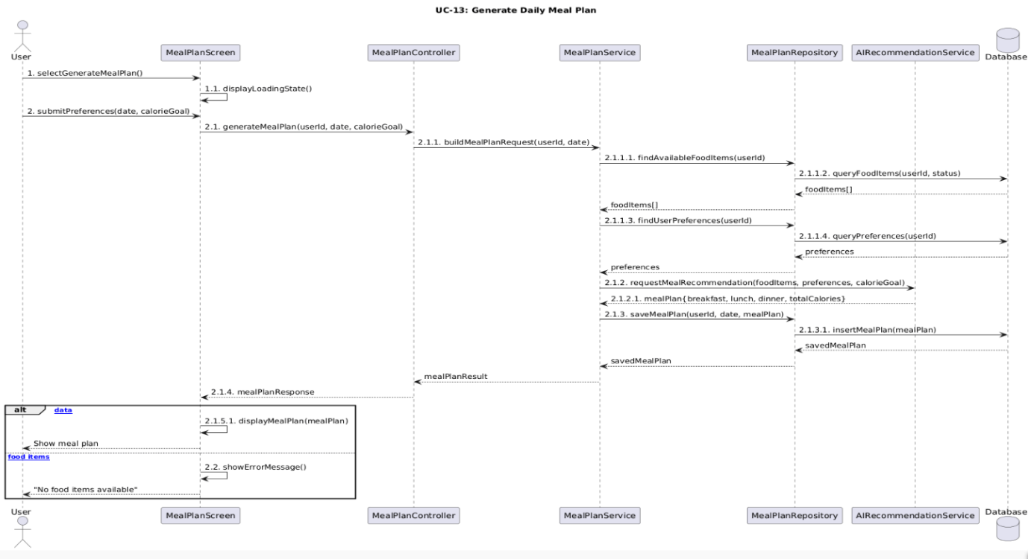

UC-14: Calculate Meal Calories

Use Case Specification
Use Case ID and Name: | UC-14 - Calculate Meal Calories
Created By: | Nguyen Tien Dung | Date Created: | June-10, 2026
Primary Actor: | User | Secondary Actors: | AI Recommendation Service
Trigger: | User views a meal plan or selects a specific meal and requests calorie calculation.
Description: | The system calculates and displays estimated calorie information for a selected meal or the entire daily meal plan. The AI Recommendation Service estimates calories based on food item nutritional data. Results are labeled as estimates. Premium users can view detailed macro breakdowns (protein, carbohydrates, fat).
Preconditions: | PRE-1: User is authenticated and logged in.  PRE-2: A meal plan or individual meal has been generated (UC-13) or selected.  PRE-3: Nutrition data for the relevant food items is available in the system.
Post–conditions: | POST-1: Estimated calorie count for the meal or daily plan is displayed. POST-2: For Premium users, macro breakdown (protein, carbs, fat) is also displayed.  POST-3: Calorie data is labeled as estimated.
Normal Flow: | 14.0.1 - User selects a meal or daily plan to view calorie information.  14.0.2 - System retrieves the ingredients of the selected meal.  14.0.3 - System queries nutrition data for each ingredient from the database. 14.0.4 - System or AI Recommendation Service calculates total estimated calories.  14.0.5 - System displays estimated calorie total labeled as 'Estimated Nutrition'.  14.0.6 - [Premium] System additionally displays macros: protein (g), carbohydrates (g), fat (g).
Alternative Flows: | 14.1 - Free User Request for Macros:  14.1.1 - At step 14.0.6, if the user is a free user and attempts to view macro details, system displays 'Upgrade to Premium to view detailed nutrition reports.'  14.1.2 - Flow returns to step 14.0.5 (only calories are shown). .
Exceptions: | 1.EX - Missing nutrition data: If nutrition data for an ingredient is unavailable, system estimates using AI and displays a note 'Nutrition data for [item] is estimated.'  2.EX - AI Service unavailable: System displays a generic error and advises the user to try again later.
Priority: | High, Must Have
Frequency of Use: | Multiple times per day per active user
Business Rules: | BR-27, BR-28
Other Information: | All calorie values are estimates. Nutrition data may be updated by the Administrator (UC-26). Premium access is required for macro-level detail.
Assumptions: | A1: Standard serving sizes are used when exact quantities are not recorded. A2: AI may estimate calories when no official nutrition data is on record.

ID | Business Rule | Business Rule Description
BR-27 | Calorie Estimation | Calories shown by the system are estimated values and should be displayed as estimated nutrition information.
BR-28 | Basic vs Premium Nutrition | Free users can view basic calorie information. Premium users can view detailed macro analysis and nutrition charts.

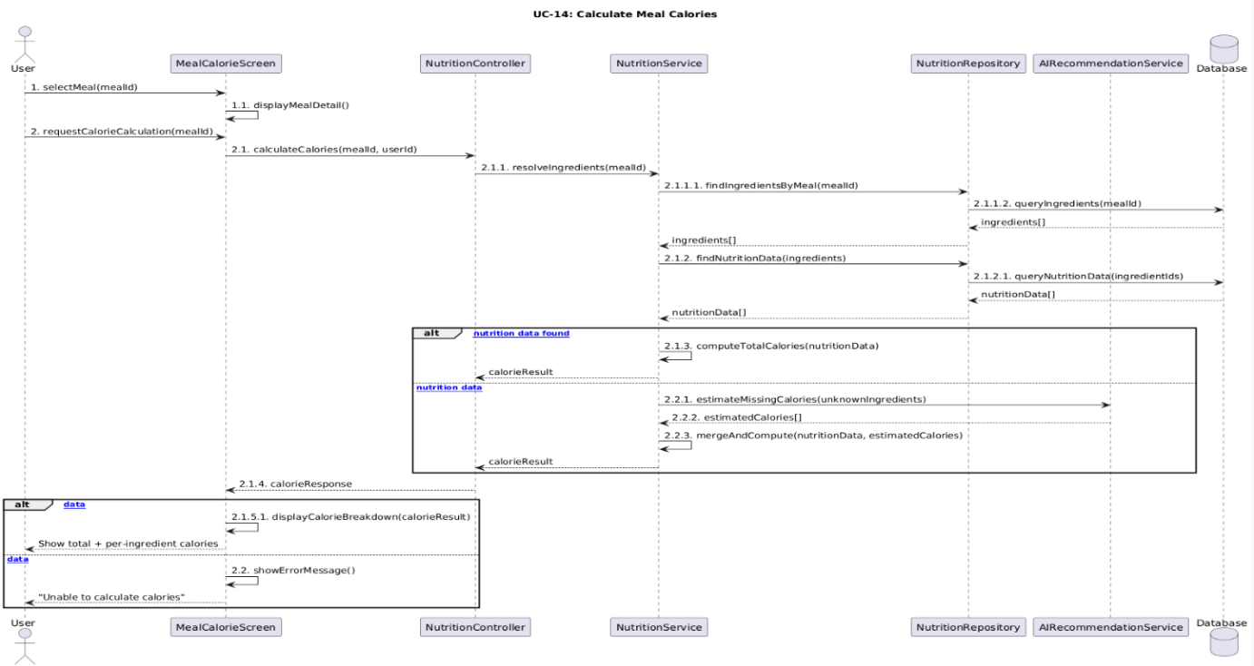

UC-15: Extract Recipe from Video

Use Case Specification
Use Case ID and Name: | UC-15 - Extract Recipe from Video
Created By: | Nguyen Tien Dung | Date Created: | June-10, 2026
Primary Actor: | User | Secondary Actors: | External Video Platform, AI Recommendation Service
Trigger: | User provides a video link from a supported external platform and requests recipe extraction.
Description: | The user submits a URL from a supported video platform (e.g., YouTube). The system fetches the video content and passes it to the AI Recommendation Service, which extracts recipe information including ingredients, steps, and estimated calories. The extracted recipe is labeled as VIDEO_EXTRACTED or AI_GENERATED and presented to the user for review before being saved.
Preconditions: | PRE-1: User is authenticated and logged in.  PRE-2: The provided URL must be from a supported video platform.  PRE-3: The AI Recommendation Service is available.
Post–conditions: | POST-1: Extracted recipe (ingredients, steps, estimated calories) is displayed to the user.  POST-2: Recipe is labeled VIDEO_EXTRACTED or AI_GENERATED. POST-3: If confirmed by user, the recipe is saved to the system for future use in meal plans.
Normal Flow: | 15.0.1 - User navigates to the Recipe section and selects 'Extract Recipe from Video'.  15.0.2 - User enters a valid video URL from a supported platform.  15.0.3 - System validates the URL format and confirms the platform is supported.  15.0.4 - System sends the URL to the AI Recommendation Service.  15.0.5 - AI Recommendation Service fetches video metadata/transcript from the External Video Platform and extracts recipe information (ingredients, quantities, preparation steps, estimated calories).  15.0.6 - System receives extracted recipe and labels it as VIDEO_EXTRACTED.  15.0.7 - System displays the extracted recipe for user review.  15.0.8 - User reviews and confirms the recipe.  15.0.9 - System saves the confirmed recipe for use in meal planning.
Alternative Flows: | 15.1 - Partial Extraction:  15.1.1 - At step  15.0.5, AI extracts only partial recipe data (e.g., missing some ingredients). 15.1.2 - System displays extracted data with missing fields highlighted. 15.1.3 - User manually fills in missing fields and confirms.  15.1.4 - System labels recipe as AI_GENERATED and saves.  15.2 - User Discards Recipe:  15.2.1 - At step 15.0.8, user chooses to discard the recipe.  15.2.2 - System discards the result; nothing is saved.
Exceptions: | 1.EX - Invalid or unsupported URL: System displays 'Please provide a valid video link from a supported platform.' and returns to step 15.0.2.  2.EX - Video content not accessible: If the external platform denies access or the video is private, system displays an error and asks the user to try a different link.  3.EX - AI extraction failure: If the AI cannot identify recipe content in the video, system notifies the user 'No recipe found in this video.' and suggests manual entry. 15.0.E4 - Network failure: System shows a generic error; no data is saved.
Priority: | Medium – Should Have
Frequency of Use: | Occasional, a few times per week per active user
Business Rules: | BR-29, BR-30, BR-22
Other Information: | Recipes extracted from video are not immediately used in official recommendations until reviewed. Administrator may also review AI-generated recipe data per UC-29.
Assumptions: | A1: Supported platforms include YouTube and other publicly accessible video services.  A2: The AI can process video metadata, captions, or transcripts to extract recipe steps and ingredients.

ID | Business Rule | Business Rule Description
BR-29 | Video Recipe Source | Recipe extraction from video requires a valid video link from a supported external platform.
BR-30 | Extracted Recipe Label | Recipes extracted from videos must be marked as VIDEO_EXTRACTED or AI_GENERATED.
BR-22 | AI Result Confirmation | AI-generated data must be confirmed by the user or reviewed by the Administrator before becoming official data.

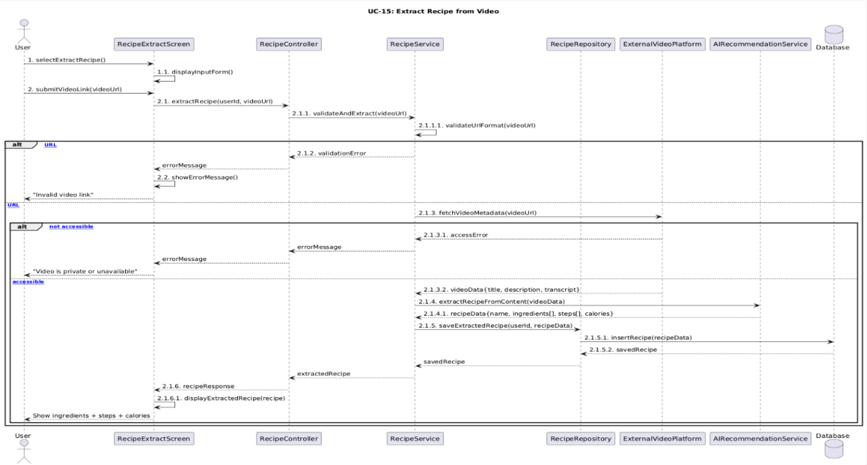

UC-16: Create Shopping List

Use Case Specification
Use Case ID and Name: | UC-16 Create Shopping List
Created By: | Vo Pham My | Date Created: | June-10, 2026
Primary Actor: | User | Secondary Actors:
Trigger: | The users selects the “Create Shopping List” function.
Description: | This use case allows the user to create a shopping list based on missing ingredients, meal plan suggestions, or personal needs.
Preconditions: | PRE-1: The user has logged in to the system.  PRE-2: The user has permission to access the shopping list feature.
Post–conditions: | POST-1: A new shopping list is created and saved to the database.  POST-2: The shopping list is linked to the user account.  POST-3: The user can view and add items to the shopping list.
Normal Flow: | 16.0.1 The user opens the Shopping List screen.  16.0.2 The system displays existing shopping lists, if any.  16.0.3 The user selects “Create Shopping List”.  16.0.4 The system displays the create shopping list form.  16.0.5 The user enters the shopping list name and optional note.  16.0.6 The user submits the form.  16.0.7 The system validates the input data.  16.0.8 The system creates a new shopping list with status ACTIVE.  16.0.9 The system saves the shopping list to the database.  16.0.10 The system displays a success message and shows the created shopping list.
Alternative Flows: | 1-AF: Create shopping list from missing ingredients  At step 16.0.3, the user creates a shopping list from a meal plan or recipe. The system collects missing ingredients and creates a shopping list automatically. The user can review and confirm before saving.  2-AF: Create default shopping list  At step 16.0.5, if the user does not enter a name, the system creates a default name such as “Shopping List - Current Date”.
Exceptions: | 1-EX: Missing required information  If the required information is missing, the system highlights the missing fields and asks the user to complete them.  2-EX: Database save failed  If the system cannot save the shopping list, it displays an error message and does not create the list.  3-EX: Network connection lost  If the network connection is lost, the system shows a connection error and allows the user to retry.
Priority: | High, Must Have
Frequency of Use: | Several times per week
Business Rules: | BR-03, BR-31
Other Information: | The shopping list should support manual creation and automatic creation from missing ingredients.
Assumptions: | The user understands which ingredients or food items need to be purchased.

ID | Business Rule | Business Rule Description
BR-03 | User Authentication Required | Users must log in before using food inventory, shopping list, meal plan, premium, or family features.
BR-31 | Shopping List Item Validation | A shopping list item must include item name, quantity, and unit before it can be saved.

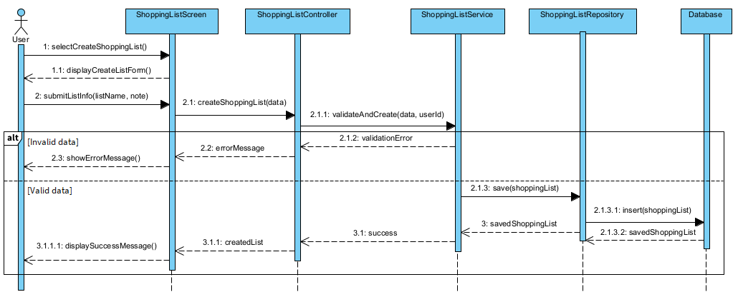

UC-17: Add Item to Shopping List

Use Case Specification
Use Case ID and Name: | UC-17 Add Item to Shopping List
Created By: | Vo Pham My | Date Created: | June-10, 2026
Primary Actor: | User | Secondary Actors:
Trigger: | The user selects a shopping list and chooses “Add Item”.
Description: | This use case allows the user to add a food item or missing ingredient to an existing shopping list.
Preconditions: | PRE-1: The user has logged in to the system.  PRE-2: At least one active shopping list exists.  PRE-3: The user has permission to update the selected shopping list.
Post–conditions: | POST-1: The new item is added to the selected shopping list.  POST-2: The shopping list is updated in the database.  POST-3: The updated shopping list is displayed to the user.
Normal Flow: | 17.0.1 The user opens a shopping list.  17.0.2 The system displays all current items in the shopping list.  17.0.3 The user selects “Add Item”.  17.0.4 The system displays the add item form.  17.0.5 The user enters item name, quantity, unit, and optional reason.  17.0.6 The user submits the form.  17.0.7 The system validates item name, quantity, and unit.  17.0.8 The system adds the item to the selected shopping list.  17.0.9 The system saves the updated shopping list to the database.  17.0.10 The system displays the updated shopping list.
Alternative Flows: | 1-AF: Add item from meal plan  At step 17.0.3, the user selects missing ingredients from a meal plan. The system fills the item name, quantity, and reason automatically. The user confirms before saving.  2-AF: Add item from video recipe  At step 17.0.3, the user adds missing ingredients from an extracted recipe. The system fills suggested items automatically. The user can edit quantity before saving.
Exceptions: | 1-EX: Invalid quantity  If the quantity is less than or equal to 0, the system asks the user to enter a valid quantity.  2-EX: Missing item name or unit  If item name or unit is missing, the system highlights the missing field.  3-EX: Shopping list not found  If the selected shopping list no longer exists, the system shows an error message and returns to the shopping list screen.
Priority: | High, Must Have
Frequency of Use: | Several times per week
Business Rules: | BR-03, BR-31
Other Information: | The system should prevent empty or invalid shopping items from being saved.
Assumptions: | The selected shopping list is active and belongs to the user or a shared household workspace that the user can update.

ID | Business Rule | Business Rule Description
BR-03 | User Authentication Required | Users must log in before using food inventory, shopping list, meal plan, premium, or family features.
BR-31 | Shopping List Item Validation | A shopping list item must include item name, quantity, and unit before it can be saved.

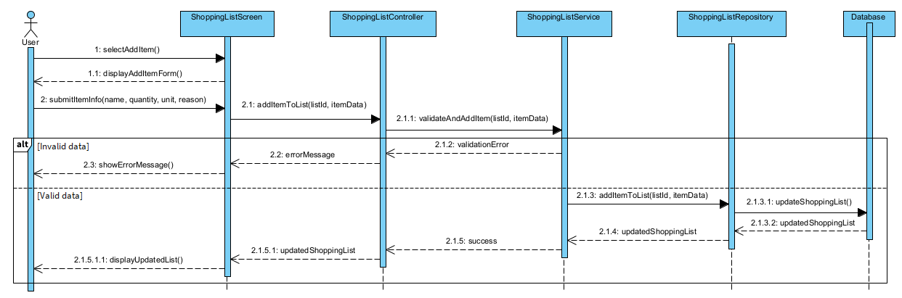

UC-18: Mark Item as Purchased

Use Case Specification
Use Case ID and Name: | UC-18 Mark Item as Purchased
Created By: | Vo Pham My | Date Created: | June-10, 2026
Primary Actor: | User | Secondary Actors:
Trigger: | The user selects an item in the shopping list and marks it as purchased.
Description: | This use case allows the user to mark a shopping list item as purchased after buying it. The user can also choose whether to add the purchased item to the food inventory.
Preconditions: | PRE-1: The user has logged in to the system.  PRE-2: The shopping list exists and contains at least one item.  PRE-3: The user has permission to update the selected shopping list.
Post–conditions: | POST-1: The selected item is marked as purchased.  POST-2: The shopping list is updated in the database.  POST-3: If the user chooses to add the item to inventory, a new food item creation process is started.
Normal Flow: | 18.0.1 The user opens a shopping list.  18.0.2 The system displays shopping list items with purchase status.  18.0.3 The user selects an item and marks it as purchased.  18.0.4 The system asks whether the user wants to add the purchased item to food inventory.  18.0.5 The user confirms the purchase status.  18.0.6 The system updates the item status to PURCHASED.  18.0.7 The system saves the updated shopping list.  18.0.8 The system displays the updated item status.
Alternative Flows: | 1-AF: Add purchased item to inventory  At step 18.0.4, the user chooses to add the purchased item to inventory. The system opens the Add Food Item form and pre-fills item name, quantity, and unit. The user enters source type, expiry date, and storage location before saving.  2-AF: Mark item as not purchased  If an item was marked as purchased by mistake, the user can uncheck it. The system updates the item status back to NOT_PURCHASED.
Exceptions: | 1-EX: Item not found  If the selected item no longer exists, the system displays an error message.  2-EX: Update failed  If the system cannot update item status, the item remains unchanged and the system displays an error message.  3-EX: Inventory limit reached  If the user chooses to add the item to inventory but has reached the Free plan inventory limit, the system asks the user to remove old items or upgrade to Premium.
Priority: | High, Must Have
Frequency of Use: | Several times per week
Business Rules: | BR-03, BR-32, BR-05, BR-06
Other Information: | Marking an item as purchased does not automatically add it to inventory unless the user confirms.
Assumptions: | The user updates shopping list status after buying items.

ID | Business Rule | Business Rule Description
BR-03 | User Authentication Required | Users must log in before using food inventory, shopping list, meal plan, premium, or family features.
BR-05 | Free Inventory Limit | Free users can manage only one main storage location and a limited number of food items, such as 30–50 items.
BR-06 | Premium Multi-storage Access | Premium users can create and manage multiple storage locations such as refrigerator, freezer, pantry, and kitchen cabinet.
BR-05 | Free Inventory Limit | Free users can manage only one main storage location and a limited number of food items, such as 30–50 items.

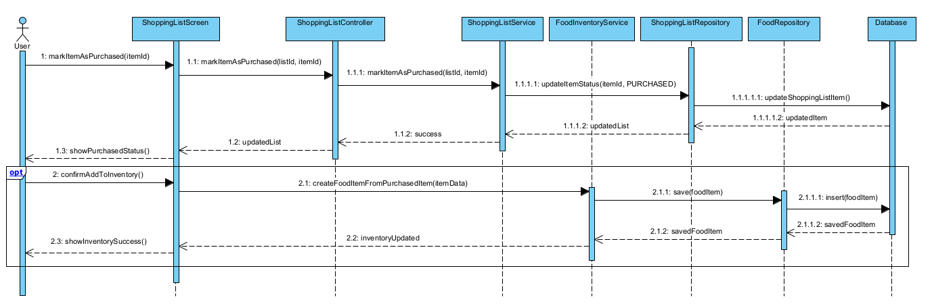

UC-19: Share Family Shopping

Use Case Specification
Use Case ID and Name: | UC-19 Share Family Shopping List
Created By: | Vo Pham My | Date Created: | June-10, 2026
Primary Actor: | Premium User | Secondary Actors: | Family Member
Trigger: | The Premium User selects the “Share Shopping List” or “Family Cloud” function.
Description: | This use case allows a Premium User to share shopping lists and synchronize shopping list updates with family members in real time or near real time.
Preconditions: | PRE-1: The user has logged in to the system.  PRE-2: The user has an active Premium subscription.  PRE-3: The user has created or joined a household workspace.  PRE-4: At least one family member is invited or already belongs to the household workspace.
Post–conditions: | POST-1: The shopping list is shared with selected family members.  POST-2: Family members can view or update the shared shopping list based on their permissions.  POST-3: Updates are synchronized across family members’ devices.
Normal Flow: | 19.0.1 The Premium User opens the Family Cloud or Shopping List screen.  19.0.2 The system displays available shopping lists.  19.0.3 The Premium User selects a shopping list to share.  19.0.4 The system displays sharing options and family members.  19.0.5 The Premium User selects family members and assigns permissions.  19.0.6 The Premium User confirms sharing.  19.0.7 The system validates Premium status and member permissions.  19.0.8 The system shares the shopping list with selected family members.  19.0.9 The system synchronizes the shopping list across devices.  19.0.10 The system displays a success message.
Alternative Flows: | 1-AF: Invite new family member  At step 19.0.4, if the family member is not in the household workspace, the Premium User sends an invitation. The system sends an invite link or notification to the family member.  2-AF: Family member updates shared list  After the list is shared, a Family Member adds, edits, or marks an item as purchased. The system synchronizes the update to all members who have access.
Exceptions: | 1-EX: User is not Premium  If the user does not have an active Premium subscription, the system denies access and suggests upgrading to Premium.  2-EX: Family member has no permission  If a family member does not have update permission, the system allows view-only access or blocks the action.  3-EX: Synchronization failed  If real-time synchronization fails, the system stores the latest local change and retries synchronization when the connection is restored.  4-EX: Invitation failed  If the invitation cannot be sent, the system displays an error message and allows the Premium User to retry.
Priority: | Medium, Should Have
Frequency of Use: | Several times per week for family users
Business Rules: | BR-03, BR-07, BR-08, BR-33
Other Information: | Family Cloud is a Premium feature. The system should clearly show permission levels such as owner, editor, and viewer.
Assumptions: | Family members use registered accounts and accept the household invitation before accessing shared data.

ID | Business Rule | Business Rule Description
BR-03 | User Authentication Required | Users must log in before using food inventory, shopping list, meal plan, premium, or family features.
BR-07 | Premium Family Cloud Access | Family Cloud synchronization is available only for Premium users.
BR-08 | Family Member Permission | Family members can view or update shared inventory and shopping lists only if they have permission from the household owner.
BR-33 | Real-time Family Sync | For Premium users, shared inventory and shopping list updates must be synchronized with family members in real time or near real time.

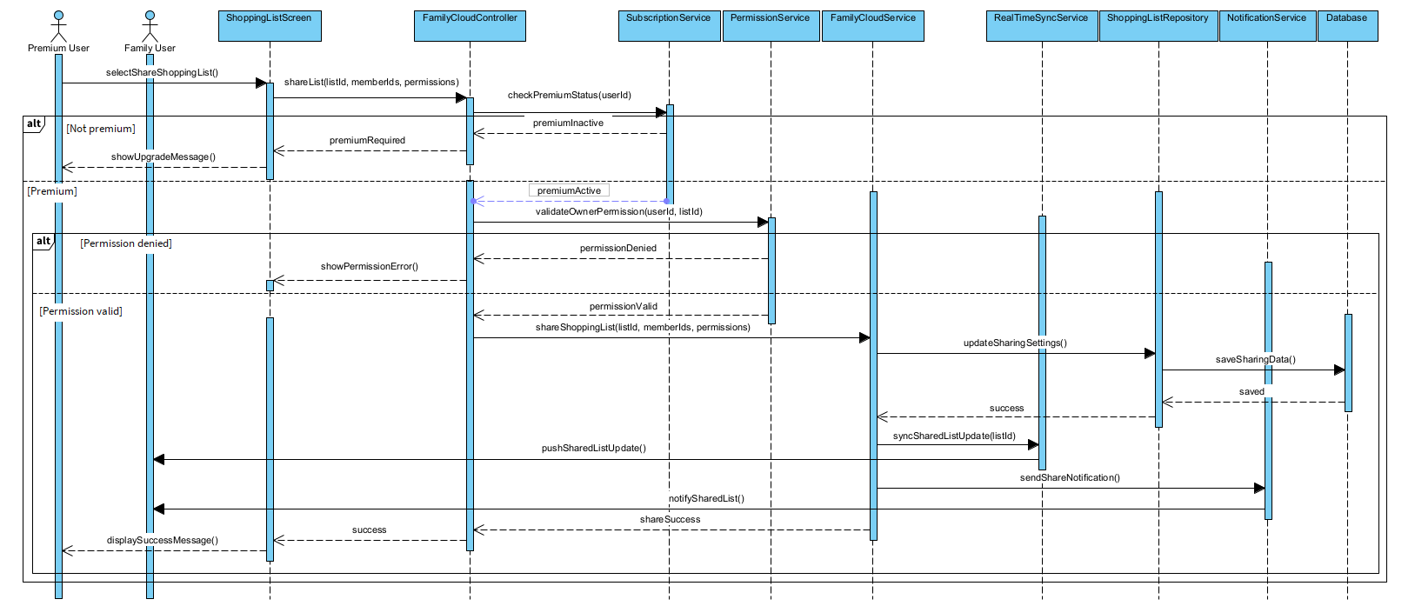

UC-20: Purchase Premium Plan

Use Case Specification
Use Case ID and Name: | UC-20 Purchase Premium Plan
Created By: | Vo Pham My | Date Created: | June-10, 2026
Primary Actor: | User | Secondary Actors: | Payment Gateway
Trigger: | The user selects a Premium plan and clicks “Purchase”.
Description: | This use case allows the user to purchase a Premium subscription plan to unlock Premium features such as multiple storage locations, Family Cloud synchronization, detailed nutrition reports, and advanced tracking features.
Preconditions: | PRE-1: The user has logged in to the system.  PRE-2: At least one active Premium plan is available.  PRE-3: The Payment Gateway is available.
Post–conditions: | POST-1: A payment transaction is created.  POST-2: If payment is successful, the user’s subscription status is updated to ACTIVE.  POST-3: Premium features are unlocked for the user.  POST-4: Payment history is saved in the system.
Normal Flow: | 20.0.1 The user opens the Premium Plan screen.  20.0.2 The system displays available Premium plans and benefits.  20.0.3 The user selects a Premium plan.  20.0.4 The system displays plan details, price, duration, and payment options.  20.0.5 The user confirms the purchase.  20.0.6 The system creates a payment transaction with status PENDING.  20.0.7 The system redirects the user to the Payment Gateway.  20.0.8 The user completes payment through the Payment Gateway.  20.0.9 The Payment Gateway sends payment result to the system.  20.0.10 The system verifies the payment result.  20.0.11 The system updates the transaction status to SUCCESS.  20.0.12 The system activates the Premium subscription.  20.0.13 The system displays a successful purchase message.
Alternative Flows: | 1-AF: User cancels payment  At step 20.0.8, the user cancels the payment. The Payment Gateway returns a cancelled result. The system updates the transaction status to CANCELLED and keeps the user on the Free plan.  2-AF: Payment is pending  At step 20.0.9, if the Payment Gateway returns a pending result, the system keeps the transaction as PENDING and informs the user that Premium will be activated after payment confirmation.  3-AF: User already has active Premium  At step 20.0.3, if the user already has an active Premium plan, the system allows renewal or extension instead of creating a duplicate subscription.
Exceptions: | 1-EX: Payment Gateway unavailable  If the Payment Gateway is unavailable, the system displays an error message and does not create a successful payment.  2-EX: Payment verification failed  If the system cannot verify the payment result, the transaction remains PENDING and Premium is not activated.  3-EX: Payment failed  If payment fails, the system updates the transaction status to FAILED and shows a failure message.  4-EX: Duplicate transaction detected  If the system detects a duplicate transaction request, it blocks the duplicate payment and shows the latest transaction status.
Priority: | Medium, Should Have
Frequency of Use: | Monthly, yearly, or when the user upgrades to Premium
Business Rules: | BR-03, BR-10, BR-11
Other Information: | The system must not activate Premium features based only on the frontend payment screen. Premium must be activated only after the backend verifies the payment result from the Payment Gateway.
Assumptions: | The Payment Gateway provides a valid payment result callback or response that the backend can verify.

ID | Business Rule | Business Rule Description
BR-03 | User Authentication Required | Users must log in before using food inventory, shopping list, meal plan, premium, or family features.
BR-10 | Payment Confirmation Required | Premium access is activated only after the Payment Gateway confirms a successful payment.
BR-11 | Subscription Expiration | When a Premium subscription expires or is cancelled, Premium-only actions must be disabled. Existing premium data may remain viewable but cannot be extended with premium actions.

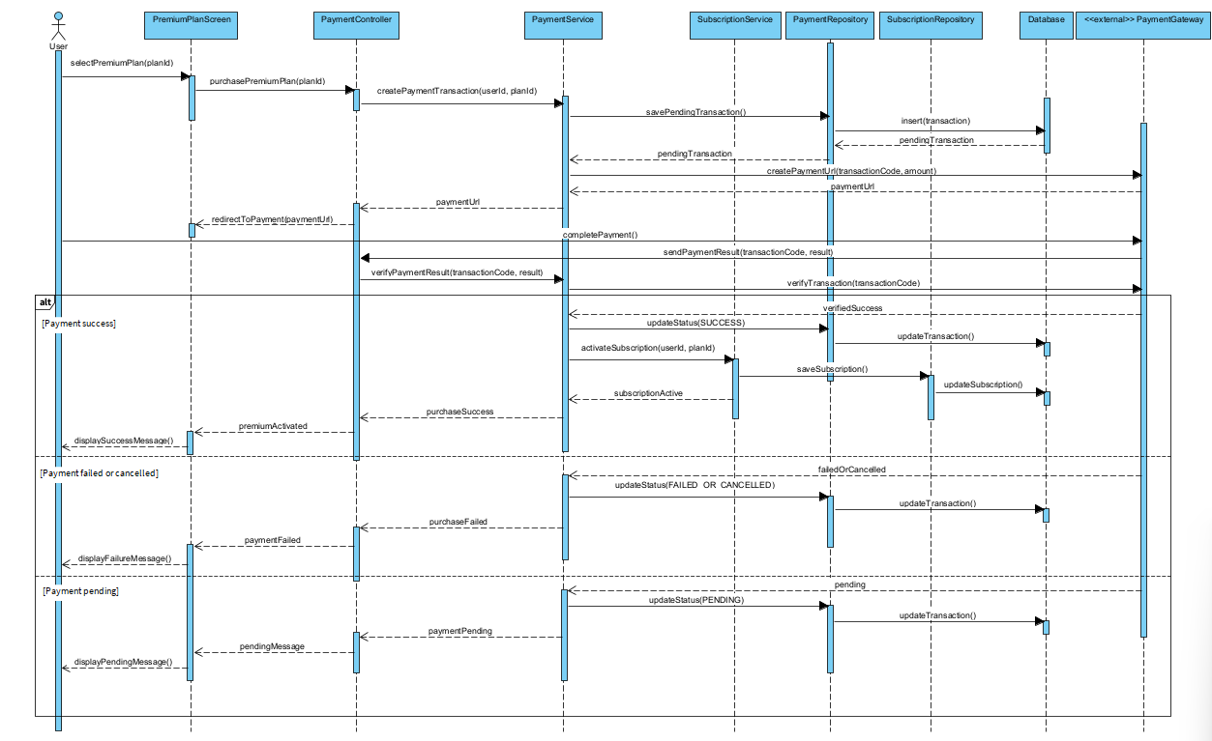

UC-21: View Nutrition Macro Report

Use Case Specification
Use Case ID and Name: | UC-21 - View Nutrition Macro Report
Created By: | Nguyen Tien Dung | Date Created: | June-10, 2026
Primary Actor: | Premium User | Secondary Actors: | AI Recommendation Service
Trigger: | Premium user navigates to the Nutrition Report section and selects a reporting period (weekly or monthly).
Description: | The system generates and displays a detailed nutrition macro report for the Premium user, showing aggregated protein, carbohydrate, fat, and calorie intake over a selected time period (weekly or monthly). The report is based on meal plan history and logged food consumption. Charts and summary statistics are included. This feature is exclusive to Premium subscribers. .
Preconditions: | PRE-1: User is authenticated and logged in.  PRE-2: User holds an active Premium subscription.  PRE-3: User has meal plan or consumption history for the selected period.
Post–conditions: | POST-1: A macro report (protein, carbohydrates, fat, calories) for the selected period is displayed.  POST-2: Report includes visual charts (weekly or monthly view).  POST-3: Totals and averages are displayed per day/week.
Normal Flow: | 21.0.1 - Premium user navigates to the Nutrition Report section.  21.0.2 - User selects a reporting period: Weekly or Monthly.  21.0.3 - System verifies the user's Premium subscription status.  21.0.4 - System retrieves meal plan history and food consumption logs for the selected period.  21.0.5 - AI Recommendation Service aggregates macro data: total and average protein (g), carbohydrates (g), fat (g), and calories per day.  21.0.6 - System displays the report with charts (bar/line charts by day or week) and summary statistics.  21.0.7 - User reviews the nutrition macro report.
Alternative Flows: | 21.1 - Switch Reporting Period:  21.1.1 - At step 21.0.7, user changes the reporting period (e.g., from Weekly to Monthly).  21.1.2 - System repeats steps 21.0.4–21.0.6 for the new period.  21.2 - Insufficient Data for Period:  21.2.1 - At step 21.0.4, system finds only partial data (some days missing). 21.2.2 - System displays available data and notes 'Data not available for all days in this period.' Missing days are shown as zero or empty.
Exceptions: | 1.EX - Non-Premium user access: If a free user navigates to this section, system displays 'This feature is available for Premium users only.' with an option to upgrade. Use case terminates.  2.EX - Expired Premium subscription: System detects subscription expiry, disables new report generation, and shows 'Your Premium plan has expired. Renew to access detailed reports.'  3.EX - No data for selected period: If no meal history exists for the selected period, system displays 'No nutrition data available for this period.' 21.0.E4 - AI Service unavailable: System displays an error and advises the user to try again later.
Priority: | Medium – Should Have (Premium Feature)
Frequency of Use: | Weekly or monthly per Premium user
Business Rules: | BR-04, BR-09, BR-11, BR-27, BR-28
Other Information: | All macro values are based on estimated nutrition data (BR-27). Past premium data may remain viewable after subscription expiry but cannot be refreshed until renewed (BR-11).
Assumptions: | A1: Meal plans and logged consumption are stored per user with timestamps. A2: Charts are rendered client-side using nutrition data returned by the server.

ID | Business Rule | Business Rule Description
BR-04 | Role-based Access Control | Only authorized roles can access their allowed functions. Premium features are restricted to Premium Users.
BR-09 | Premium Nutrition Report Access | Detailed macro reports, including protein, carbohydrate, fat, and weekly/monthly charts, are available only for Premium users.
BR-11 | Subscription Expiration | When a Premium subscription expires or is cancelled, Premium-only actions must be disabled. Existing premium data may remain viewable but cannot be extended with premium actions.
BR-27 | Calorie Estimation | Calories shown by the system are estimated values and should be displayed as estimated nutrition information.
BR-28 | Basic vs Premium Nutrition | Free users can view basic calorie information. Premium users can view detailed macro analysis and nutrition charts.
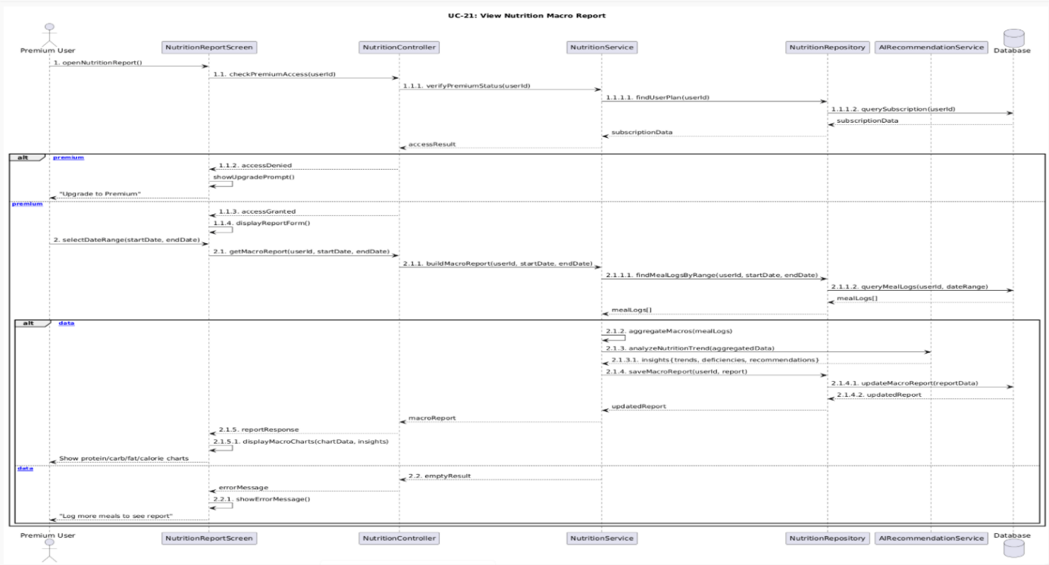

UC-22 Create Storage Location
UC ID and Name: | UC-22 Create Storage Location
Created By: | ThangTD | Date Created: | June-10, 2026
Primary Actor: | Premium User | Secondary Actors:
Trigger: | The user selects the "Create Storage Location" or "Add New Storage Zone" function within the inventory settings interface.
Description: | This use case allows an authorized Premium User to scale their kitchen management capabilities by creating multiple customized storage structures (e.g., secondary refrigerator, deep freezer, basement pantry, spice rack). This expands their asset grouping choices beyond the basic default storage allocation.
Preconditions: | PRE-1: The user has logged in to the system (BR-03).  PRE-2: The user account possesses an active Premium User role token (BR-04, BR-06).
Postconditions: | POST-1: A new, custom storage location object is successfully instantiated and registered in the user's database scope.  POST-2: The newly created location instantly becomes selectable within all food addition and modification forms (UC-04, UC-07).
Normal Flow: | 22.0.1 The user navigates to the Storage Location Configuration or Inventory Settings panel.  22.0.2 The system displays the user's current list of active storage locations.  22.0.3 The user taps the "Create Storage Location" button.  22.0.4 The system checks the user's role status to verify active premium access entitlements (BR-04, BR-06).  22.0.5 The system displays the creation form, requesting a Location Name, Icon/Label type, and an optional description notes field.  22.0.6 The user fills in the form fields (e.g., Name: "Garage Deep Freezer", Type: Freezer) and submits.  22.0.7 The system validates that the input fields are populated and do not violate naming constraints.  22.0.8 The system commits the new storage zone record to the database under the user's unique account ID.  22.0.9 The system displays a success confirmation toast and refreshes the location management viewport.
Alternative Flows: | 1-AF: Standard User Attempts Access via Direct Link Override / Expired Premium Fallback  At step 22.0.4, the verification module discovers that the user's session role is evaluated as a standard User (either due to a Free tier profile or because a previous Premium subscription has expired or been cancelled) (BR-05, BR-11).  The system halts the form generation process.  The system displays a feature lock wall overlay modal: "Upgrade to Premium: Free accounts are limited to managing one main storage location. Upgrade now to unlock custom refrigerators, freezers, and pantries."  The user is redirected to the Premium Checkout payment flow (UC-10 / BR-10) or returned safely to their default dashboard page.
Exceptions: | 1-EX: Duplicate Location Name Label  At step 22.0.7, the validation engine discovers that the user already has an active storage asset utilizing the exact same name string (e.g., trying to create a second location named "Pantry" when "Pantry" already exists).  The system blocks the database submission transaction to prevent downstream mapping confusion.  The system highlights the Location Name field and fires an inline error alert: "A storage location with this name already exists. Please choose a unique name."  The input form remains open for user modification.  2-EX: Database Save Failure Instance  At step 22.0.8, an unexpected cloud service error or database transaction exception blocks the save script.  The system rolls back the database attempt and shows an error message: "System Error: Failed to initialize the new storage location. Please try again later."  The form parameters remain preserved so the user does not lose typed data string assets.
Priority: | High, Must Have
Frequency of Use: | Low (Occurs occasionally during initial account setup, kitchen rearrangement phases, or seasonal storage expansions).
Business Rules: | BR-04: Ensures strict Role-Based Access Control filters differentiate standard users from Premium tier operations.  BR-05 / BR-06: Declares structural limits where Free accounts are bottlenecked to one main location zone, whereas Premium accounts gain unlimited multi-storage generation powers (refrigerator, freezer, pantry, etc.).  BR-11: Enforces subscription lifecycle constraints, gracefully locking down creation workflows the moment a premium subscription terminates.  BR-34: Maintains distinct domain boundaries; users can build personal instance storage configurations, but they cannot rewrite master system-wide baseline categories (which remain restricted to Administrator accounts).
Other Information:
Assumptions: | The user has not reached any absolute hardcoded hardware database record ceiling values set by cloud architecture configurations.
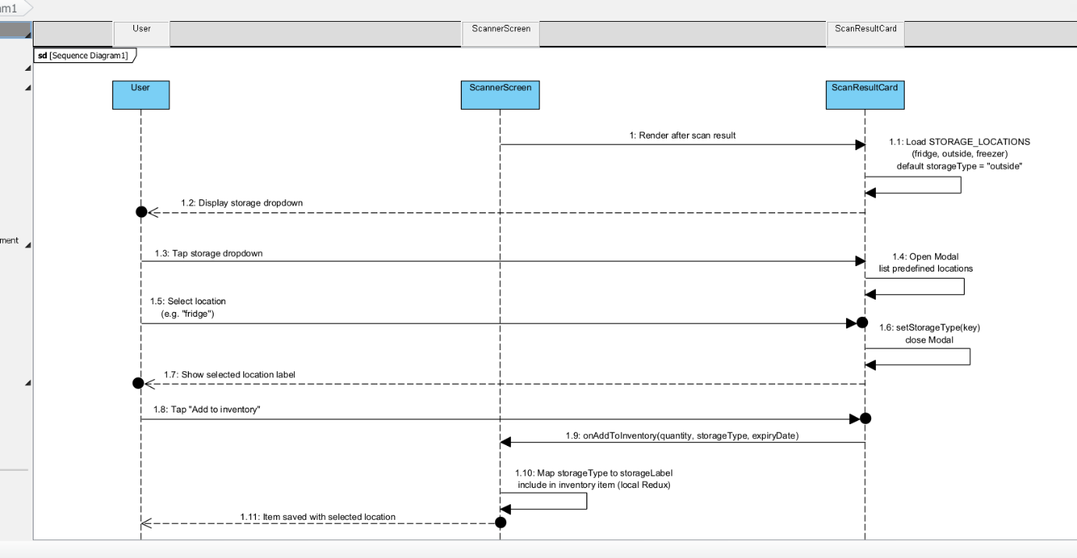

UC-23 Create Food Category
 | Use Case Specification
UC ID and Name: | UC-23 Create Food Category
Created By: | Nguyen Duc Huy | Date Created: | 10/06/2026
Primary Actor: | Administrator | Secondary Actors: | None
Trigger: | The Administrator selects the function to create a new food category in the admin data maintenance module.
Description: | This use case allows the Administrator to create a new food category for classifying food items in the system. The created category can be used in food inventory, storage rules, nutrition data, and recipe management.
Preconditions: | PRE-1: The Administrator has logged into the system.  PRE-2: The Administrator has permission to access the admin data maintenance function.  PRE-3: The Food Category Management function is available.
Postconditions: | POST-1: A new food category is created and saved to the database.  POST-2: The new category becomes available for food classification.  POST-3: The new food category can be used by related modules such as food inventory, storage rules, nutrition, and recipes.
Normal Flow: | 23.0.1 The Administrator opens the Food Category Management screen.  23.0.2 The system displays the list of existing food categories.  23.0.3 The Administrator selects “Create Food Category”.  23.0.4 The system displays the create food category form.  23.0.5 The Administrator enters category information such as category name, description, and status.  23.0.6 The Administrator submits the form.  23.0.7 The system validates the input data.  23.0.8 The system checks the Administrator’s permission.  23.0.9 The system saves the new food category to the database.  23.0.10 The system displays a success message and shows the updated category list.
Alternative Flows: | 1-AF: Create inactive food category  At step 23.0.5, the Administrator sets the category status as inactive. The system saves the category but does not make it available for normal user selection until it is activated.  2-AF: Cancel category creation  At step 23.0.5, the Administrator cancels the creation process. The system returns to the Food Category Management screen and no data is saved.
Exceptions: | 1-EX: Missing required information  If required information is missing, the system highlights the missing fields and asks the Administrator to complete them.  2-EX: Permission denied  If the current account does not have Administrator permission, the system denies access and displays an authorization error message.  3-EX: Database save failed  If the system cannot save the food category, it displays an error message and does not create the category.  4-EX: Network connection lost  If the network connection is lost during submission, the system shows a connection error and allows the Administrator to retry.
Priority: | High, Must Have
Frequency of Use: | Several times per month, especially when new food groups are added to the system.
Business Rules: | BR-04, BR-34
Other Information: | The system should validate input before saving data. If creation fails, no partial food category data should be stored in the database.
Assumptions: | The Administrator understands the food classification structure used by the system.

ID | Business Rule | Business Rule Description
BR-04 | Role-based Access Control | Only authorized roles can access their allowed functions. User, Premium User, Family Member, and Administrator have different permissions.
BR-34 | Administrator Data Permission | Only Administrators can create or update food categories, storage rules, nutrition data, recipe data, and AI-generated official data.

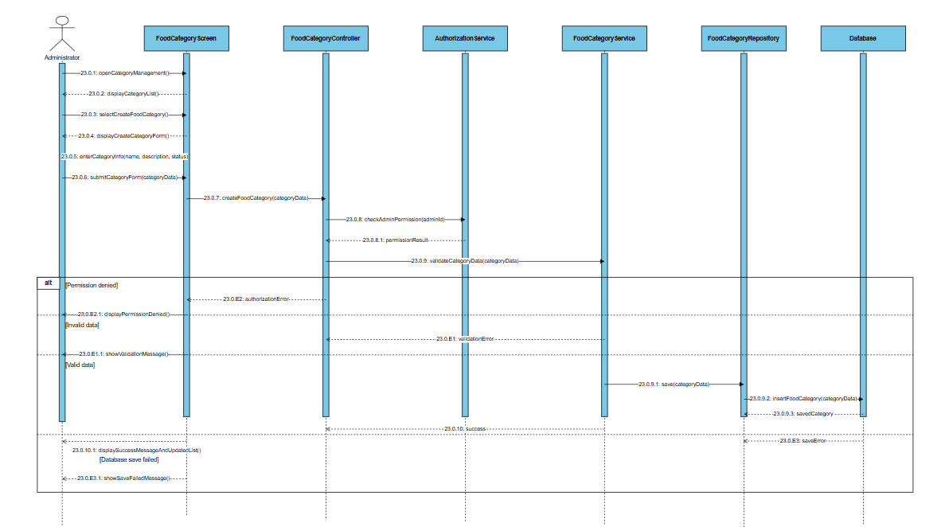

UC-24 Update Food Category

Use Case Specification
Use Case ID and Name: | UC-24 Update Food Category
Created By: | Nguyen Duc Huy | Date Created: | June-10, 2026
Primary Actor: | Administrator | Secondary Actors:
Trigger: | The Administrator selects an existing food category and chooses the “Update Food Category” function.
Description: | This use case allows the Administrator to update existing food category information such as category name, description, and status. The updated category information will be used by related modules in the system.
Preconditions: | PRE-1: The Administrator has logged into the system.  PRE-2: The Administrator has permission to access the admin data maintenance function.  PRE-3: The selected food category already exists in the system.
Post–conditions: | POST-1: The selected food category is updated and saved to the database.  POST-2: The updated category information is reflected in related modules.  POST-3: If the category is deactivated, it is hidden from normal user selection but remains in the database.
Normal Flow: | 24.0.1 The Administrator opens the Food Category Management screen.  24.0.2 The system displays the list of existing food categories.  24.0.3 The Administrator selects a food category to update.  24.0.4 The system displays the current information of the selected category.  24.0.5 The Administrator modifies category information such as category name, description, or status.  24.0.6 The Administrator submits the update request.  24.0.7 The system validates the updated information.  24.0.8 The system checks the Administrator’s permission.  24.0.9 The system updates the food category in the database.  24.0.10 The system displays a success message and refreshes the category list.
Alternative Flows: | 1-AF: Deactivate food category  At step 24.0.5, the Administrator changes the category status to inactive. The system deactivates the category instead of permanently deleting it, especially when it is already used by food items, recipes, or storage rules.  2-AF: Cancel category update  At step 24.0.5, the Administrator cancels the update process. The system returns to the category list and keeps the original data unchanged.
Exceptions: | 1-EX: Category not found  If the selected category no longer exists, the system displays a not found message and returns to the category list.  2-EX: Invalid updated information  If the updated information is invalid or missing required fields, the system displays validation messages and asks the Administrator to correct the data.  3-EX: Permission denied  If the current account does not have Administrator permission, the system denies access and displays an authorization error message.  4-EX: Database update failed  If the system cannot update the category, it displays an error message and keeps the previous category information unchanged.  5-EX: Network connection lost  If the network connection is lost during submission, the system shows a connection error and allows the Administrator to retry.
Priority: | High, Must Have
Frequency of Use: | Several times per month, depending on changes in food classification requirements.
Business Rules: | BR-04, BR-34, BR-35
Other Information: | The system should not permanently delete food categories that are already used by other system data. If the update fails, the previous category data must remain unchanged.
Assumptions: | The system supports category status such as active and inactive.

ID | Business Rule | Business Rule Description
BR-04 | Role-based Access Control | Only authorized roles can access their allowed functions. User, Premium User, Family Member, and Administrator have different permissions.
BR-34 | Administrator Data Permission | Only Administrators can create or update food categories, storage rules, nutrition data, recipe data, and AI-generated official data.
BR-35 | Admin Data Deactivation | Food categories, storage rules, or recipes that are already used by the system should be deactivated instead of permanently deleted.

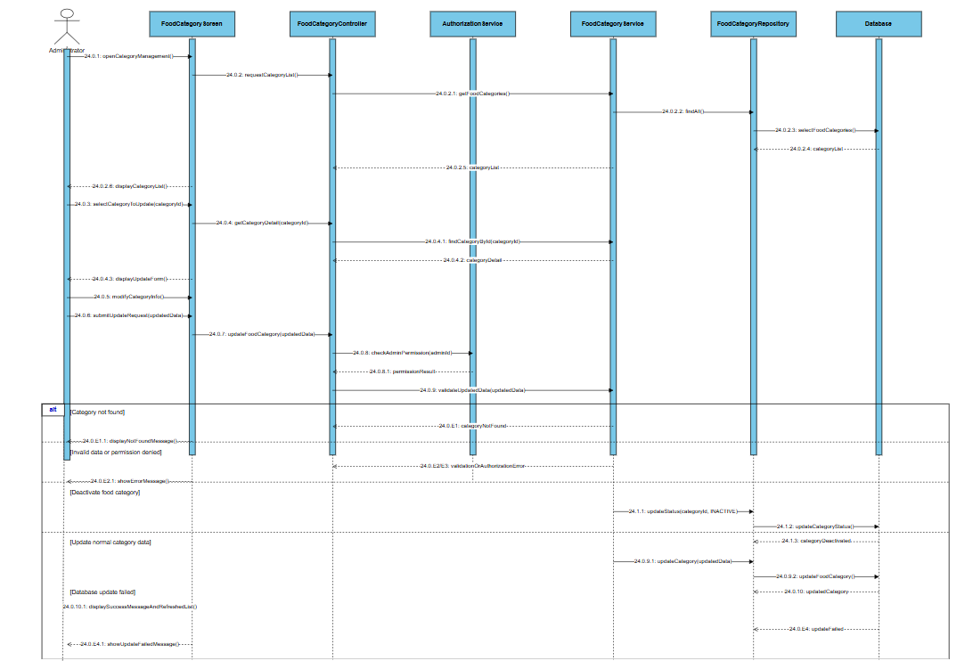

UC-25 Configure Storage Rule
UC ID and Name: | UC-25 Configure Storage Rule
Created By: | Le Dinh Nhat Nam | Date Created: | June-10, 2026
Primary Actor: | User | Secondary Actors: | None
Trigger: | The Administrator accesses the Data Maintenance dashboard and selects "Storage Rules".
Description: | The Administrator creates or updates official storage rules for specific food categories and storage locations. These rules are used system-wide to give storage suggestions to end-users
Preconditions: | PRE-1: The user is logged in as an Administrator (BR-04)
Postconditions: | POST-1: The storage rule is successfully saved and becomes active system-wide.
Normal Flow: | 25.0.1 The Administrator navigates to the "Storage Rules Configuration" panel.  25.0.2 The system displays a list of existing storage rules and food categories.  25.0.3 The Administrator selects "Add New Rule" or clicks to edit an existing rule.  25.0.4 The Administrator inputs/updates data: Food Category, Storage Location (Fridge, Freezer, Pantry), Shelf-life duration, and Storage Tips.  25.0.5 The Administrator submits the form.  25.0.6 The system validates the inputs (e.g., duration > 0, category exists).  25.0.7 The system saves the rule to the database, ensuring only authorized roles can perform this (BR-34).  25.0.8 The system displays a success message.
Alternative Flows: | 1-AF: Deactivate Instead of Delete  At step 25.0.3, if the Admin wants to remove an existing rule that is currently being used by users, they must select "Deactivate". The system sets its status to inactive rather than deleting it completely (BR-35).
Exceptions: | 1-EX: Unauthorized Access  If a normal user or Premium user attempts to access this API, the system rejects it with a 403 Forbidden error (BR-04, BR-34).
Priority: | High, Must Have
Frequency of Use: | Low (System setup and periodic data updates)
Business Rules: | BR-04 (Role-based Access Control),  BR-34 (Administrator Data Permission),  BR-35 (Admin Data Deactivation).
Other Information: | These rules override AI suggestions (BR-23).
Assumptions: | Food categories (UC-23) already exist in the system.
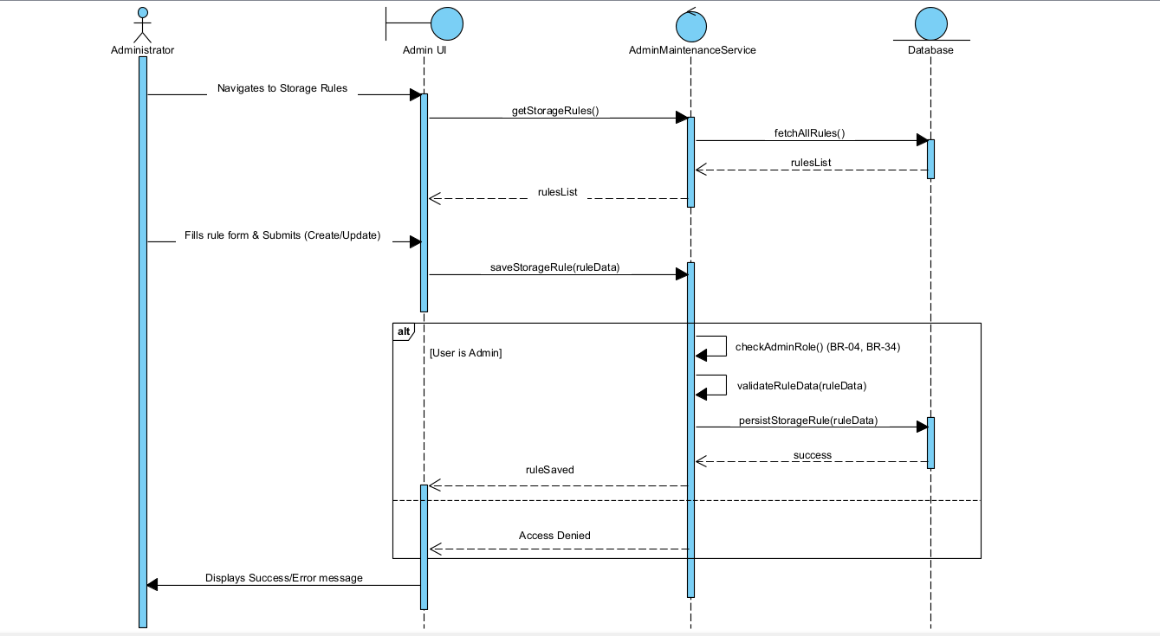

UC-26 Update Nutrition Data

Use Case Specification
Use Case ID and Name: | UC-26 Update Nutrition Data
Created By: | Nguyen Duc Huy | Date Created: | June-10, 2026
Primary Actor: | Administrator | Secondary Actors:
Trigger: | The Administrator selects a food item, ingredient, or nutrition record and chooses the “Update Nutrition Data” function.
Description: | This use case allows the Administrator to update calorie and nutrition information used by the system. The updated nutrition data supports calorie estimation, meal recommendation, and nutrition reports.
Preconditions: | PRE-1: The Administrator has logged in to the system.  PRE-2: The Administrator has permission to maintain nutrition data.  PRE-3: The selected food item, ingredient, or nutrition record exists in the system.  PRE-4: The nutrition data management function is available.
Post–conditions: | POST-1: Nutrition data is updated and saved to the database.  POST-2: Updated nutrition information becomes available for calorie estimation, meal recommendation, and nutrition reports.  POST-3: If the nutrition data is AI-generated, it becomes official only after Administrator review.
Normal Flow: | 26.0.1 The Administrator opens the Nutrition Data Management screen.  26.0.2 The system displays the list of food items, ingredients, or nutrition records.  26.0.3 The Administrator searches for and selects a nutrition record to update.  26.0.4 The system displays the current nutrition information such as calories, protein, carbohydrate, fat, fiber, and serving unit.  26.0.5 The Administrator modifies the nutrition values.  26.0.6 The Administrator submits the update request.  26.0.7 The system validates the nutrition values and measurement unit.  26.0.8 The system checks the Administrator’s permission.  26.0.9 The system saves the updated nutrition data to the database.  26.0.10 The system updates related calorie estimation and nutrition calculation data.  26.0.11 The system displays a success message.
Alternative Flows: | 1-AF: Review AI-generated nutrition data  At step 26.0.4, the selected nutrition data is AI-generated. The Administrator reviews and confirms the data before it becomes official nutrition data.  2-AF: Update missing nutrition fields  At step 26.0.4, some nutrition fields are empty. The Administrator enters the missing values, and the system validates them before saving.  3-AF: Cancel nutrition update  At step 26.0.5, the Administrator cancels the update process. The system returns to the nutrition data list and keeps the original data unchanged.
Exceptions: | 1-EX: Nutrition record not found  If the selected nutrition record does not exist, the system displays a not found message.  2-EX: Invalid nutrition value  If calories or nutrition values are negative, non-numeric, or invalid, the system displays validation errors and asks the Administrator to correct them.  3-EX: Permission denied  If the current account does not have Administrator permission, the system denies access and displays an authorization error message.  4-EX: Database update failed  If the system cannot update the nutrition data, it displays an error message and keeps the previous values unchanged.  5-EX: Network connection lost  If the network connection is lost during submission, the system shows a connection error and allows the Administrator to retry.
Priority: | High, Must Have
Frequency of Use: | Weekly or whenever nutrition data needs to be corrected or expanded.
Business Rules: | BR-04, BR-22, BR-27, BR-34
Other Information: | Nutrition values displayed by the system should be treated as estimated nutrition information. If the update fails, the system must keep the previous nutrition data unchanged.
Assumptions: | The Administrator uses reliable nutrition sources when updating nutrition data.

ID | Business Rule | Business Rule Description
BR-04 | Role-based Access Control | Only authorized roles can access their allowed functions. User, Premium User, Family Member, and Administrator have different permissions.
BR-22 | AI Result Confirmation | AI-generated expiry dates, storage suggestions, recipe data, or nutrition data must be confirmed by the user or reviewed by the Administrator before becoming official data.
BR-27 | Calorie Estimation | Calories shown by the system are estimated values and should be displayed as estimated nutrition information.
BR-34 | Admin Data Deactivation | Food categories, storage rules, or recipes that are already used by the system should be deactivated instead of permanently deleted.

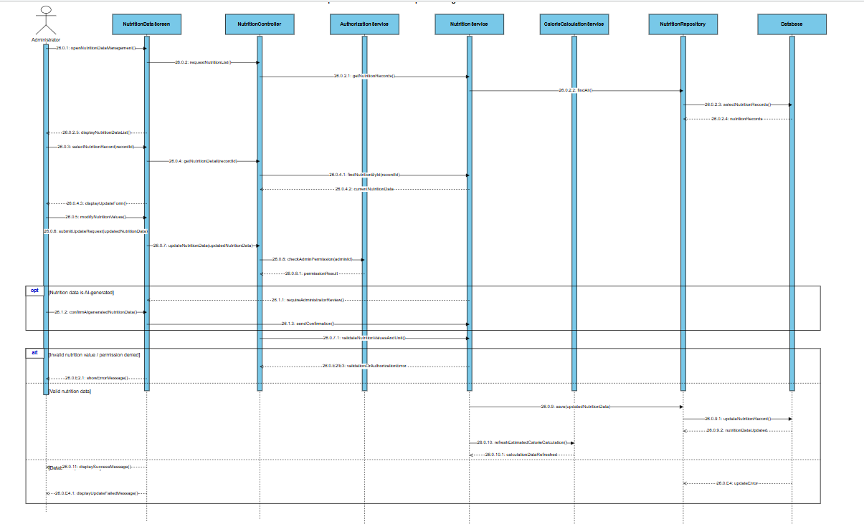

UC-27 Create Recipe

Use Case Specification
Use Case ID and Name: | UC-27 Create Recipe
Created By: | Nguyen Duc Huy | Date Created: | June-10, 2026
Primary Actor: | Administrator | Secondary Actors:
Trigger: | The Administrator selects the “Create Recipe” function.
Description: | This use case allows the Administrator to create sample recipes for the meal recommendation feature. A recipe may include recipe name, description, ingredients, cooking steps, serving size, food category, preparation time, and estimated calories.
Preconditions: | PRE-1: The Administrator has logged into the system.  PRE-2: The Administrator has permission to create recipe data.  PRE-3: Food categories and ingredient or nutrition data are available in the system.
Post–conditions: | POST-1: A new recipe is created and saved to the database.  POST-2: The recipe becomes available for meal recommendation if its status is active.  POST-3: The recipe calories are stored as estimated nutrition information.  POST-4: If the recipe data is AI-generated, it becomes official only after Administrator review.
Normal Flow: | 27.0.1 The Administrator opens the Recipe Management screen.  27.0.2 The system displays the list of existing recipes.  27.0.3 The Administrator selects “Create Recipe”.  27.0.4 The system displays the create recipe form.  27.0.5 The Administrator enters recipe information such as recipe name, description, category, ingredients, cooking steps, serving size, preparation time, and status.  27.0.6 The Administrator submits the form.  27.0.7 The system validates the recipe information.  27.0.8 The system checks the Administrator’s permission.  27.0.9 The system calculates or verifies estimated calories based on ingredient nutrition data.  27.0.10 The system saves the new recipe to the database.  27.0.11 The system displays a success message and shows the created recipe.
Alternative Flows: | 1-AF: Create recipe as draft  At step 27.0.5, the Administrator sets the recipe status as draft. The system saves the recipe but does not use it for meal recommendation.  2-AF: Create recipe from AI-generated data  At step 27.0.5, the recipe data is AI-generated. The Administrator reviews and confirms the recipe data before saving it as official recipe data.  3-AF: Manual calorie input  At step 27.0.9, if automatic calorie calculation is not available, the Administrator manually enters estimated calorie information.  4-AF: Cancel recipe creation  At step 27.0.5, the Administrator cancels the creation process. The system returns to the Recipe Management screen and no recipe is saved.
Priority: | High, Must Have
Frequency of Use: | Several times per month
Business Rules: | BR-04, BR-22, BR-25, BR-27, BR-34
Other Information: | Recipe data is used by the meal recommendation module. Incomplete recipes should be saved as draft and should not be shown in recommendation results.
Assumptions: | The Administrator provides valid recipe content and checks the recipe carefully before publishing it.

ID | Business Rule | Business Rule Description
BR-04 | Role-based Access Control | Only authorized roles can access their allowed functions. User, Premium User, Family Member, and Administrator have different permissions.
BR-22 | AI Result Confirmation | AI-generated expiry dates, storage suggestions, recipe data, or nutrition data must be confirmed by the user or reviewed by the Administrator before becoming official data.
BR-27 | Calorie Estimation | Calories shown by the system are estimated values and should be displayed as estimated nutrition information.
BR-34 | Admin Data Deactivation | Food categories, storage rules, or recipes that are already used by the system should be deactivated instead of permanently deleted.

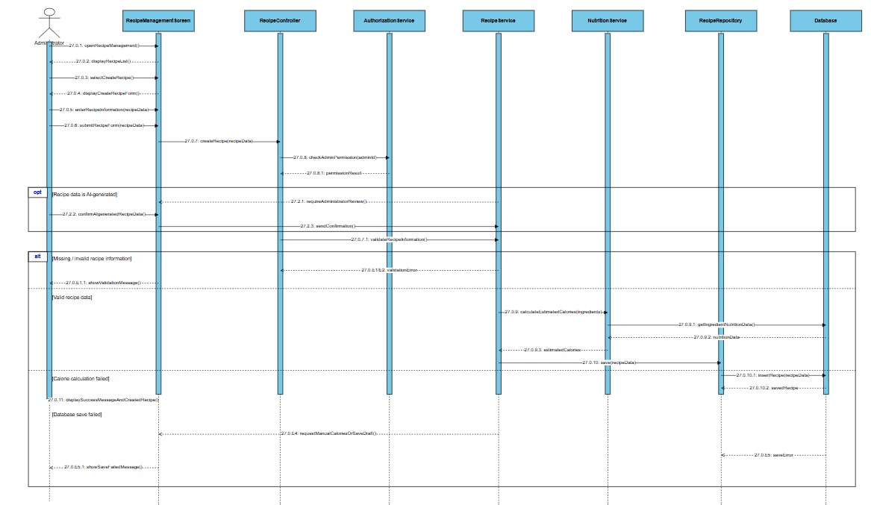

UC-28 Update Recipe

Use Case Specification
Use Case ID and Name: | UC-28 Update Recipe
Created By: | Nguyen Duc Huy | Date Created: | June-10, 2026
Primary Actor: | Administrator | Secondary Actors:
Trigger: | The Administrator selects an existing recipe and chooses the “Update Recipe” function.
Description: | This use case allows the Administrator to update recipe information, ingredients, cooking steps, serving size, estimated calories, and recipe status. The updated recipe data will be used by the meal recommendation module.
Preconditions: | PRE-1: The Administrator has logged into the system.  PRE-2: The Administrator has permission to create recipe data.  PRE-3: The selected recipe exists in the system.
Post–conditions: | POST-1: The selected recipe is updated and saved to the database.  POST-2: Updated recipe information becomes available for meal recommendation if the recipe is active.  POST-3: Estimated calories are recalculated or verified if ingredients or serving size are changed.  POST-4: If the recipe is deactivated, it is removed from meal recommendation results but remains in the database.
Normal Flow: | 28.0.1 The Administrator opens the Recipe Management screen.  28.0.2 The system displays the list of existing recipes.  28.0.3 The Administrator searches for and selects a recipe to update.  28.0.4 The system displays the current recipe information.  28.0.5 The Administrator modifies recipe information such as name, description, ingredients, cooking steps, serving size, estimated calories, or status.  28.0.6 The Administrator submits the update request.  28.0.7 The system validates the updated recipe information.  28.0.8 The system checks the Administrator’s permission.  28.0.9 The system recalculates or verifies estimated calories if ingredients or serving size are changed.  28.0.10 The system saves the updated recipe information to the database.  28.0.11 The system displays a success message and refreshes the recipe list.
Alternative Flows: | 1-AF: Deactivate recipe  At step 28.0.5, the Administrator changes the recipe status to inactive. The system deactivates the recipe instead of permanently deleting it and removes it from meal recommendation results.  2-AF: Save updated recipe as draft  At step 28.0.5, the Administrator sets the recipe status as draft. The system saves the updated recipe but does not use it for recommendation.  3-AF: Update AI-generated recipe data  At step 28.0.4, the selected recipe is AI-generated. The Administrator reviews and updates the recipe before confirming it as official recipe data.  4-AF: Cancel recipe update  At step 28.0.5, the Administrator cancels the update process. The system returns to the recipe list and keeps the original recipe data unchanged.
Priority: | High, Must Have
Frequency of Use: | Weekly or whenever recipe information needs to be corrected or improved
Business Rules: | BR-04, BR-22, BR-25, BR-27, BR-34, BR-35
Other Information: | Recipe updates may affect meal recommendation results. If the update fails, the system must keep the previous recipe information unchanged.
Assumptions: | The Administrator reviews recipe information carefully before publishing it as active.

ID | Business Rule | Business Rule Description
BR-04 | Role-based Access Control | Only authorized roles can access their allowed functions. User, Premium User, Family Member, and Administrator have different permissions.
BR-22 | AI Result Confirmation | AI-generated expiry dates, storage suggestions, recipe data, or nutrition data must be confirmed by the user or reviewed by the Administrator before becoming official data.
BR-27 | Calorie Estimation | Calories shown by the system are estimated values and should be displayed as estimated nutrition information.
BR-34 | Admin Data Deactivation | Food categories, storage rules, or recipes that are already used by the system should be deactivated instead of permanently deleted.
BR-35 | Admin Data Deactivation | Food categories, storage rules, or recipes that are already used by the system should be deactivated instead of permanently deleted.

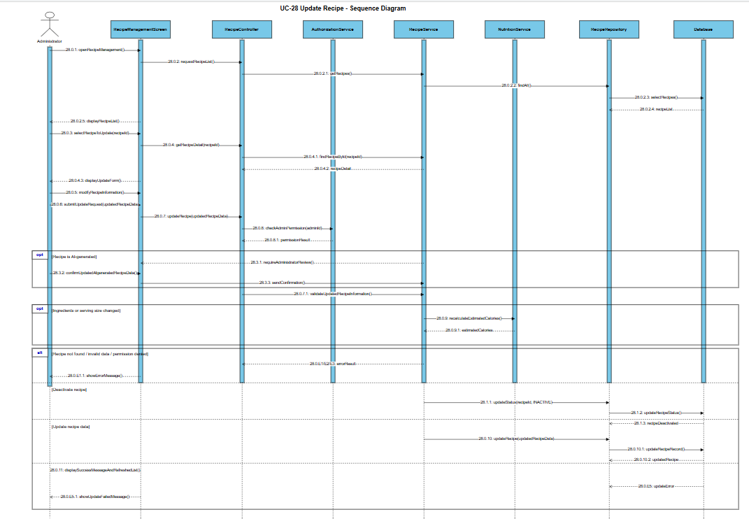

UC-29 Review AI-generated Data
UC ID and Name: | UC-29 Review AI-generated Data
Created By: | Le Dinh Nhat Nam | Date Created: | June-10, 2026
Primary Actor: | Administrator | Secondary Actors: | None
Trigger: | The Administrator accesses the "AI Data Review" module in the Admin dashboard.
Description: | The Administrator reviews AI-generated expiry rules, storage suggestions, or recipe data collected from user activities. Approved data is converted into official system data.
Preconditions: | PRE-1: The user is logged in as an Administrator (BR-04).  PRE-2: There is pending AI-generated data waiting for review.
Postconditions: | POST-1: The AI-generated data is either approved (becomes official), edited, or rejected.
Normal Flow: | 29.0.1 The Administrator navigates to the "AI Data Review" screen.  29.0.2 The system fetches a queue of pending AI-generated rules/suggestions from the database.  29.0.3 The Administrator selects a specific AI record to review.  29.0.4 The Administrator modifies parameters if necessary (e.g., adjusting an AI-predicted shelf-life from 5 days to 4 days).  29.0.5 The Administrator clicks "Approve".  29.0.6 The system promotes this data to official system data (BR-22, BR-34).  29.0.7 The system updates the status of the item in the review queue to "Resolved".
Alternative Flows: | 1-AF: Reject AI Data  At step 29.0.5, the Administrator clicks "Reject" because the AI generated inaccurate or nonsensical data.  The system discards the AI data and marks the queue item as "Rejected" without updating official rules.
Exceptions: | 1-EX: Database Conflict  At step 29.0.6, if an official rule for this exact category was just created by another admin, the system warns the Administrator and prevents overriding without explicit confirmation.
Priority: | Medium, Should Have
Frequency of Use: | Weekly / Monthly
Business Rules: | BR-04 (Role-based Access Control),  BR-22 (AI Result Confirmation),  BR-34 (Administrator Data Permission).
Other Information: | This crowd-sourcing mechanism helps the app's database grow intelligently based on real user edge cases.
Assumptions: | AI-generated fallback data is temporarily stored in a separate staging collection until reviewed.
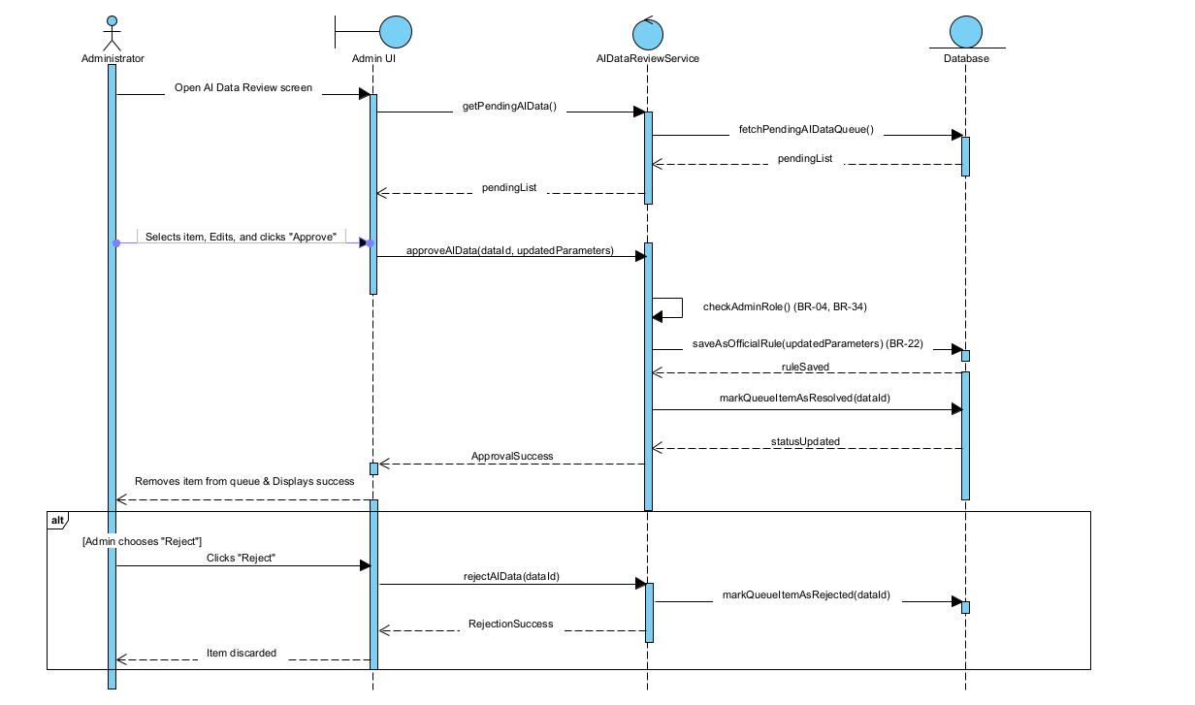

III. Design Specifications

1. <<Feature Name>>

1.1 <<SubFeature Name>>

a. <<Screen/Function Name>>
[Provide brief description of the screen/function + related UC here and other details as in the sub-sections]

UI Design
[This is to describe the UI layout (Mockup prototype) & descriptions for screen fields/components]
<<Mockup prototype>>
Field Name | Field Type | Description
Field Group Name
<<Field-Name>> | <<Field type>> | <<Field description & data initializing design>>

Database Access
[Provide the design description for the screen/function to access the database here: what table the screen/function would access, which transactions does it make (C-Create, R-Read, U-Update, or D-Delete), and how/purpose of the access (by providing Description and SQL commands)]
Table | CRUD | Description
<<Table Name>> | <<transaction(s)>> | <<Table access description: purpose, how,…>>
..

SQL Commands
[Provide the detailed SQL (select, insert, update...) which are used in implementing the screen/function]

1.2 System Access

a. User Login
This screen allows user to be authenticated to the system screens/functionalities.
Related use cases:
- UC02_Login System

UI Design
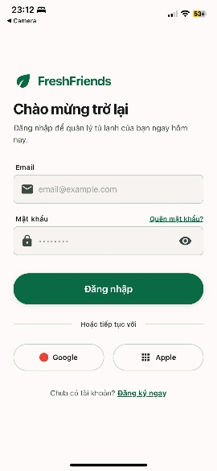

Field Name | Field Type | Description
Email* | Text Box | This is for user to input valid email address for logging in
Password* | Password Box | This is for user to input password for logging in
Login | Button | User clicks to authenticate him/herself into the system with provided email & password
Register | Button | User clicks to redirect to the User Register page for registering new user account to access the system
Forgot Password? | Hyperlink | User clicks to redirect to the Password Reset page for resetting his/her forgot password
Login with Google | Hyperlink | Allow user to login with his/her Google account
Login with Facebook | Hyperlink | Allow user to login with his/her Facebook account

Database Access
Table | CRUD | Description
User | R | Verify UserName & Password information
Setting, User | R | Specify the authorizations of the logged-in user

SQL Commands:
1/ Verify UserName & Password information
SELECT user_id, full_name, email, image_url, status
FROM user WHERE user_name = ? AND password = ?

2/ Specify the authorizations of the logged-in user
SELECT mapped_values FROM setting WHERE setting_id = ?
SELECT setting_name, mapped_values FROM setting WHERE setting_id IN (?)

b. Setting List

UI Design
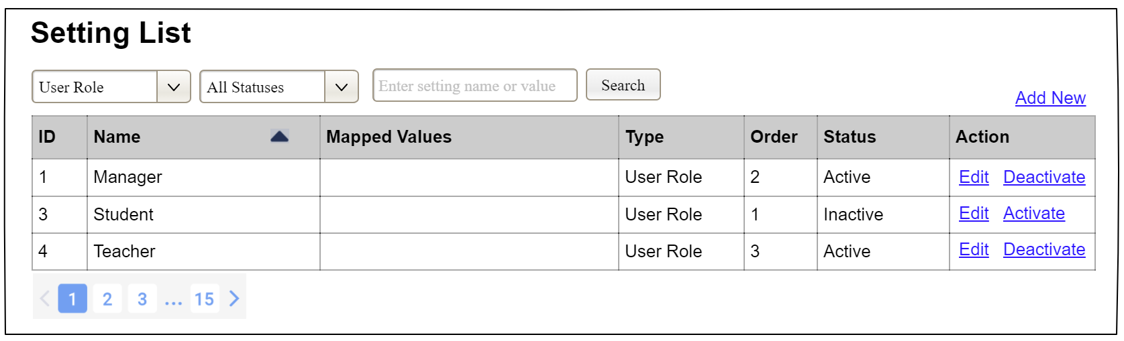

Field Name | Field Type | Description
Search Fields
Setting Type | Combo Box  Single-Choice | Filled with the list of current active setting types  Allow to filter the list by setting type;  Default value is “All Types”
Setting Status | Combo Box  Single-Choice | Values: All Statuses (default), Active, and Inactive  Allow to filter the list by status  Default value: “All Statuses”
Search Phase | Text Box  String (30) | Allow to search using the name or map values  Default value: blank
Search | Button | Click to refresh the list with the defined filter(s) and search phrase.
Add New | Hyperlink | Click to open the Setting Details page for adding new setting (master data)
Data Table
ID | Integer | Auto-increased identifier of the setting
Name | Text | Name of the setting
Mapped Values | Text | Supplementary information for the setting
Type | Text | Type of the setting
Order | Integer | Display order of the setting: the order of the setting type, displayed among the list of settings with the same type
Data Actions
Edit | icon | Click to open the Setting Details page for updating the relevant setting (master data)
Activate | icon | Shown when the data status is inactive. This is to activate the relevant setting (master data)
Deactivate | Ion | Shown when the data status is active. This is to deactivate the relevant setting (master data)

Database Access
Table | CRUD | Description
Setting | RU | Query the list of current settings from the database  Update status of a specific setting

SQL Commands:
1/ Query the list of current settings from the database
SELECT setting_id, setting_name, mapped_values, type_id, display_order, status
FROM setting WHERE (setting_type = ?) AND (status = ?) AND (setting_name LIKE ?)

2/ Update status of a specific setting
UPDATE setting SET status = ? WHERE setting_id = ?

c. Setting Details

UI Design
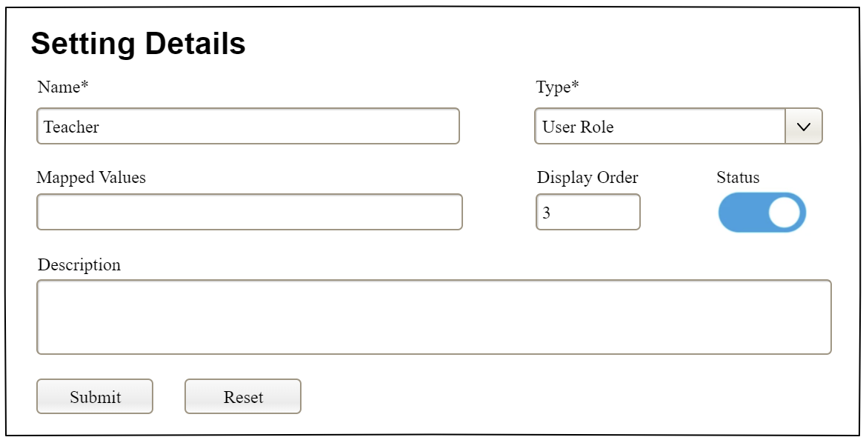

Field Name | Field Type | Description
Name* | Text Box  String (20) | Name of the setting
Type* | Combo Box  (Single Choice) | Type of the setting, filled with the list of setting types  Default value: the first type in the list
Mapped Values | Text Box  String (50) | Supplementary information for the setting (if any)
Order | Text Box  Integer (>=0) | Display order of the setting: the order of the setting type, displayed among the list of settings with the same type
Status | On/Off button | Status of the setting: Active or Inactive  Default value: Active
Description | Text Area  String (200) | Description of the setting
Submit | Button | Click to store new or updated setting details
Reset | Button | Click to reset the changes use has made on the screen fields back to the initial values when the screen is loaded

Database Access
…

IV. Appendix

1. Assumptions & Dependencies
[Record any assumptions that were made when conceiving the project and writing this vision and scope document. Note any major dependencies the project must rely upon for success, such as specific technologies, third-party vendors, development partners, or other business relationships.]
<<Sample:
AS-1: Systems with appropriate user interfaces will be available for cafeteria employees to process the expected volume of meals ordered.
AS-2: Cafeteria staff and vehicles will be available to deliver all meals for specified delivery time slots within 15 minutes of the requested delivery time.
DE-1: If a restaurant has its own on-line ordering system, the Cafeteria Ordering System must be able to communicate with it bi-directionally.
>>

2. Limitations & Exclusions
[Identify any product features or characteristics that a stakeholder might anticipate, but which are not planned to be included in the new product]

3. Business Rules
[Provide common business rules that you must follow. The information can be provided in the table format as the sample below]
<<Sample
ID | Category | Rule Definition
BR-01 | Unique Email | Each user account must use a unique email address.
BR-02 | Password Hashing | User passwords must be securely hashed before being stored in the database.
BR-03 | User Authentication Required | Users must log in before using food inventory, shopping list, meal plan, premium, or family features.
BR-04 | Role-based Access Control | Only authorized roles can access their allowed functions. User, Premium User, Family Member, and Administrator have different permissions.
BR-05 | Free Inventory Limit | Free users can manage only one main storage location and a limited number of food items, such as 30–50 items.
BR-06 | Premium Multi-storage Access | Premium users can create and manage multiple storage locations such as refrigerator, freezer, pantry, and kitchen cabinet.
BR-07 | Premium Family Cloud Access | Family Cloud synchronization is available only for Premium users.
BR-08 | Family Member Permission | Family members can view or update shared inventory and shopping lists only if they have permission from the household owner.
BR-09 | Premium Nutrition Report Access | Detailed macro reports, including protein, carbohydrate, fat, and weekly/monthly charts, are available only for Premium users.
BR-10 | Payment Confirmation Required | Premium access is activated only after the Payment Gateway confirms a successful payment.
BR-11 | Subscription Expiration | When a Premium subscription expires or is cancelled, Premium-only actions must be disabled. Existing premium data may remain viewable but cannot be extended with premium actions.
BR-12 | Food Item Required Fields | A food item must include food name, quantity, unit, source type, purchase date, expiry date, and storage location.
BR-13 | Food Source Type | Food source type must be either SUPERMARKET or MARKET.
BR-14 | Expiry Date Source | Expiry date must be marked as SCANNED, AI_PREDICTED, or MANUAL.
BR-15 | Expiry Date Validation | Expiry date should not be earlier than purchase date. If the expiry date is AI-predicted, it must be shown as an estimated value.
BR-16 | Quantity Validation | Food quantity must be greater than 0 and must include a valid unit such as g, kg, ml, bottle, pack, item, or bunch.
BR-17 | Food Status Calculation | Food status must be calculated based on expiry date: Safe, Near Expiry, Expired, or Need Check.
BR-18 | Near-expiry Rule | Food should be marked as Near Expiry when it is close to the expiry date, for example within 1–3 days.
BR-19 | Soft Delete Food Item | Deleted food items should be hidden from normal inventory views but may be kept in the database for history or reporting.
BR-20 | Supermarket Food Scanning | Supermarket food can be added by barcode scanning or OCR expiry date recognition. If scanning fails, the user must be allowed to enter the data manually.
BR-21 | Market Food AI Prediction | Food bought from traditional markets may use AI expiry prediction, but the result must be shown as estimated and editable by the user.
BR-22 | AI Result Confirmation | AI-generated expiry dates, storage suggestions, recipe data, or nutrition data must be confirmed by the user or reviewed by the Administrator before becoming official data.
BR-23 | Storage Rule Priority | Storage suggestions should use official storage rules first. If no official rule exists, the system may use AI-generated suggestions as fallback.
BR-24 | Incorrect Storage Warning | The system must warn users when a food item is stored in an unsuitable storage location.
BR-25 | Meal Plan Inventory Priority | Meal plans should prioritize available food items and near-expiry food items before suggesting new ingredients to buy.
BR-26 | User Preference Filtering | Meal recommendations must respect user preferences such as allergies, disliked foods, dietary goals, and calorie targets.
BR-27 | Calorie Estimation | Calories shown by the system are estimated values and should be displayed as estimated nutrition information.
BR-28 | Basic vs Premium Nutrition | Free users can view basic calorie information. Premium users can view detailed macro analysis and nutrition charts.
BR-29 | Video Recipe Source | Recipe extraction from video requires a valid video link from a supported external platform.
BR-30 | Extracted Recipe Label | Recipes extracted from videos must be marked as VIDEO_EXTRACTED or AI_GENERATED.
BR-31 | Shopping List Item Validation | A shopping list item must include item name, quantity, and unit before it can be saved.
BR-32 | Purchased Item Confirmation | When a shopping list item is marked as purchased, the user can choose whether to add it to the food inventory.
BR-33 | Real-time Family Sync | For Premium users, shared inventory and shopping list updates must be synchronized with family members in real time or near real time.
BR-34 | Administrator Data Permission | Only Administrators can create or update food categories, storage rules, nutrition data, recipe data, and AI-generated official data.
BR-35 | Admin Data Deactivation | Food categories, storage rules, or recipes that are already used by the system should be deactivated instead of permanently deleted.
BR-36 | Notification Permission | Expiration alerts and storage warnings can be sent only if the user enables notification permission.
BR-37 | Notification History | Important alerts should be stored in notification history even if push notification delivery fails.
>>

4. ..

